STROBE-S-2000

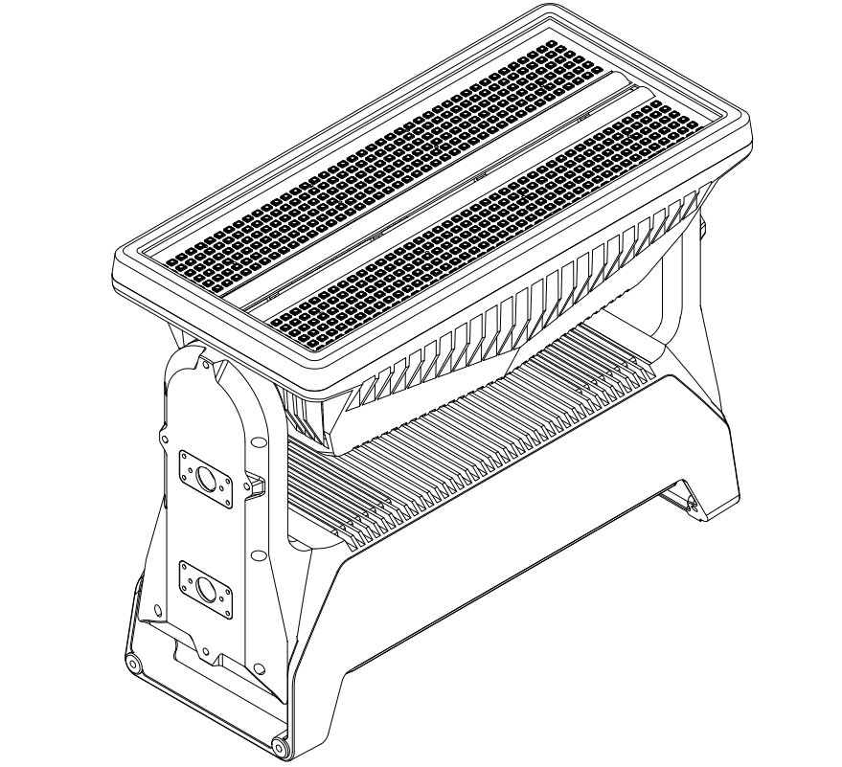

User Manual
This manual applies to v1.0 firmware and above

First use
- Please read the user manual carefully before powering up the lamp for the first time.
- This version applies to firmware version: STROBE-V1.0
- This manual covers the installation, use and maintenance of the STROBE-S2000 series.
- The information in this document is subject to change without notice. The Company and all its affiliates shall not be liable for any injury, damage, direct or indirect loss, direct or indirect economic loss.
- The Company and all its affiliates shall not be liable for any injury, damage, direct or indirect loss, or any other loss arising out of the use of, inability to use, or reliance on the information in this document.
- This unit is a multi-scenario general purpose luminaire with an IP waterproof rating of 65 for indoor and outdoor use.
- This device is intended for professional use only. It is not suitable for domestic use.
- Please read the following safety precautions carefully before installing or operating the luminaire.
- This equipment must be operated by someone who is familiar with the construction and operation of the fixture. and the hazards involved in the installation and operation.

Packaging Information

Unpack the unit and inspect it to ensure that it has not been damaged in transit

- 2 x Omega brackets with 1/4 turn fasteners/one piece folding light hooks
- 1 x Power cable with IP connector, 2 m/78 in.
- 1 x Signal cable with IP connector, 2 m/78 in.
- Safety information leaflet.
- Application notes

Important Reminder！
Always use the supplied packaging or a suitable flight case for transport and storage.
Never carry or drag the fixtures directly with connecting cables or wires.。

Page Index

First use 2
Packaging Information 3
Fixtures Appearance 6
CAD-View 7
Main technical indicators 8
Basic Information 8
Control mode 8
Cooling System 8
Effects 9
Connectors 9
Operating conditions 9
Mounting method 10
Transport 10
Intellectual property rights 10
Safety Precautions 11
External cleaning and visual inspection of luminaires 13
Security Precautions 14
Installation Precautions 15
Start installation 15
Wiring and conduit/sealing 17
Cable selection 19
Identification and terminology 22
Fault and error messages 24
Configuration of lamps and lanterns 25
Connecting DMX Control Devices 26
DMX Configuration 26
LED MAPS 28
DIMMER CURVES 29
Spectroscopy 30
Temperature vs 32
System menu 33
DMX-Charts 36
Cleaning & Maintenance 51

Fixtures Appearance
All dimensions are in millimetres. This drawing is not to scale
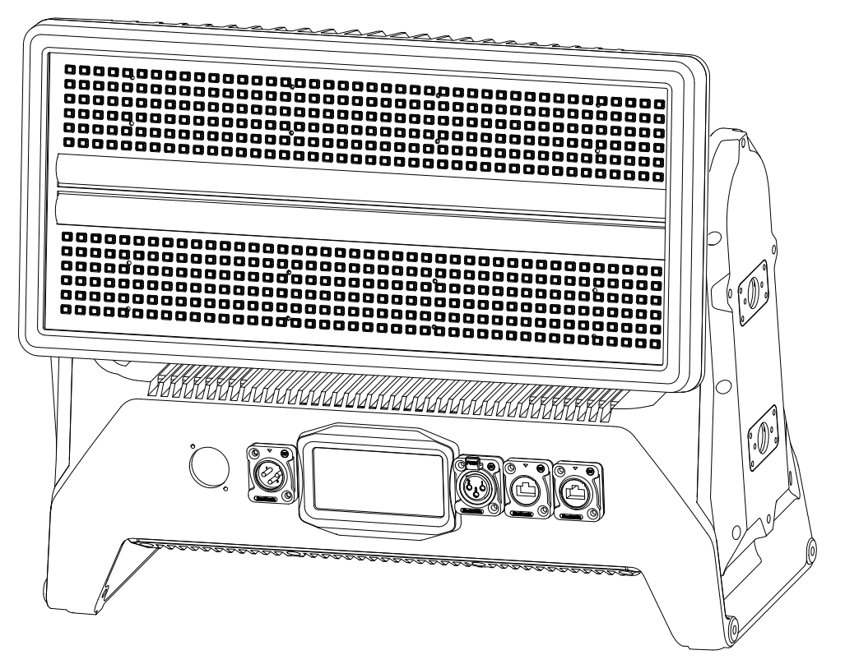

CAD-View
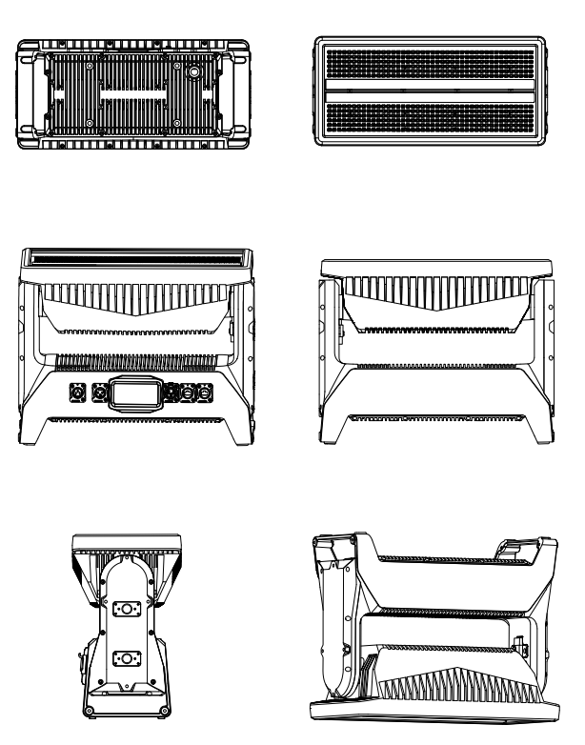

Main technical indicators

Basic Information
Light source: 504 x 1.5W-RGB LEDs
280 x 5W white LEDs (6500K Ra≥80)
Controllable zoning: RGB 14 segments
White light 28 segments
Beam angle RGB 120 ° / White 60 °
Rated power: 1500W
Peak power consumption: 1500W

Control mode
Control Mode: 8 channels / 18 channels / 25 channels / 95 channels
Display Illuminated Graphics LCD/Touch Interactive Panel
Protocol DMX-512, RDM, W-DMX ,ART-net.
RDM: Support two-way communication. Support remote address code. Channel mode setting.
Wireless DMX: 2.4 GHz W-DMX™ (optional)
Supporting networked communication via switch LAN.
Support Art-net Sacn signal decoding and forwarding function

Cooling System
Aluminium heat sink, active air cooling system
IP65 rated bi-directional PWM programmable cooling fan
Temperature controlled, overheat protection

Effects
Dimmer: 0-100% electronic dimming
4 dimming curves
5 levels of dimming speed
18 strobe modes
Customisable strobe duration 0-650hm
Extensive built-in effects library for selection
Strobe up to 24 Hz
Rich built-in library of effects to be recalled

Connectors
Signal Connections Seetronic IP65 XLR 5-pin or 3-pin input/output
Wireless communication; wireless solution - W-DMX (optional)
Power input Seetronic PowerCON TRUE1 input
Network communication: Seetronic Dual with switch interface (optional)

Operating conditions
Mains voltage: 100-240V AC / 50-60Hz
Power: 1800W
Operating temperature: -30°C / 86°F, 50°C / 122°F
Working position: Any position

Mounting method
Suspension Omega bracket / Folding one-piece bracket
Safety cable connection: Folding eyelet

Transport
Individual fixtures: Cardboard (internal and external cartons)
Air Box: 4 in 1 flight case / special order

Expandable accessories
Connecting accessories available for splicing
Enclosure colour
Standard colour: black

Intellectual property rights
Independent intellectual property rights for the exterior of the device
The control circuit of the device has independent intellectual property rights
The control software of this equipment has independent intellectual property rights


Safety Precautions

Read the following safety precautions carefully before unpacking, installing, powering up, or operating the equipment.
This fixtures are for professional use only. They are not intended for home use.

- This product must be installed in accordance with the installation specifications by a person familiar with the product's construction and safety practices.
- Always switch off/unplug the fixture before removing the cover or disassembling the product.
- Ensure that the power supply is disconnected when connecting the equipment to an AC power source.
- Ensure that the unit is electrically connected to earth (ground).
- Do not switch on the power if there is any damage to the device or power cord.
- Do not immerse the equipment in water or liquid.
- Install in a location that prevents accidental contact with the equipment.
- Install only in a well-ventilated area.
- Install at a distance of at least 0.3 metres from the object being illuminated.
- Install only in accordance with applicable building codes.
- Ensure a clearance of at least 0.3 metres around the cooling fan.
- Do not paint, cover, or modify the equipment, or filter or block the light.
- Keep all flammable or explosive materials away from the equipment.
- Allow the equipment to cool down after 15 minutes of operation before touching it.
- NOTE: The outside surface temperature of the equipment may be ≥45 °C (113 °F) after 5 minutes of operation.
- Lamp steady state ≥60 °C (140 °F).
Warning! Take steps to prevent personal injury. Do not look directly at the light source at close range.

- Take precautions to prevent injury from falling during installation work at height.
- For permanent outdoor installations, securely fasten fixtures to load-bearing surfaces using appropriate corrosion-resistant hardware.
- For temporary installations using fixtures, ensure that fasteners are securely installed and fastened with an appropriate safety wire.
- The standard safety wire safe working load (SWL) is 10 times the weight of the fixture.
- For overhead installations, secure the fixture with a suitable safety wire and always comply with relevant load dimensions, safety standards and requirements.

External cleaning and visual inspection of luminaires
- Parts of the luminaire that are directly exposed to the air, such as the external housing and the front lens, should be cleaned regularly.
- The exterior housing of the luminaire must be inspected periodically for broken parts, cracked lenses or loose screws.
- Do not use the luminaire if the lens, housing or power cord is damaged.
- If parts of the luminaire are missing, stop using it immediately and contact technical service.

Security Precautions
- When using electrical equipment, basic safety precautions should always be observed, including the following:
- Do not install near gas or electric heaters.
- Permanently installed equipment should be mounted in the following locations and heights
- The equipment should be installed in a position and at a height where it cannot be easily tampered with by unauthorised persons.
- Use of accessory equipment not recommended by the manufacturer may result in unsafe conditions.
- Do not use this equipment for other purposes.
- Have it serviced by a qualified person or an authorised service centre.
- Do not look directly into the beam for long periods of time when the luminaire is switched on.
- Under no circumstances should the luminaire be covered with any type of insulating material.

Installation Precautions
- The luminaire is IP66 rated and designed for architectural and landscape colour rendering as well as for rendering scenes for indoor and outdoor recreational activities. This means that it can
- Homeowner dust, dust entering the luminaire.
- Low pressure water jets from any direction.
When using the luminaire outdoors or in wet locations, make sure that the
- The DMX connector of the last fixture in the link should be sealed to meet Intake Protection (IP) requirements.
When selecting a location for installation of the equipment, ensure that
- Located away from public thoroughfares to avoid contact with people.
- It is not immersed or submerged in water.

Start installation
- Lights can be mounted in any orientation.
- If mounted horizontally with the beam angle down, water may accumulate in the fan well. Under normal operation, the water will evaporate. However, in areas of heavy rainfall you may wish to fabricate a rain shield over the luminaire or modify the position and orientation of the luminaire to minimise water vapour accumulation. Or modify the position and orientation of the luminaire to minimise water accumulation.
- If the fixture is to be permanently installed in the ground, remove the rubber feet from the base. and securely fasten it in the resulting hole with four corrosion-resistant mechanical fasteners appropriate for the location.
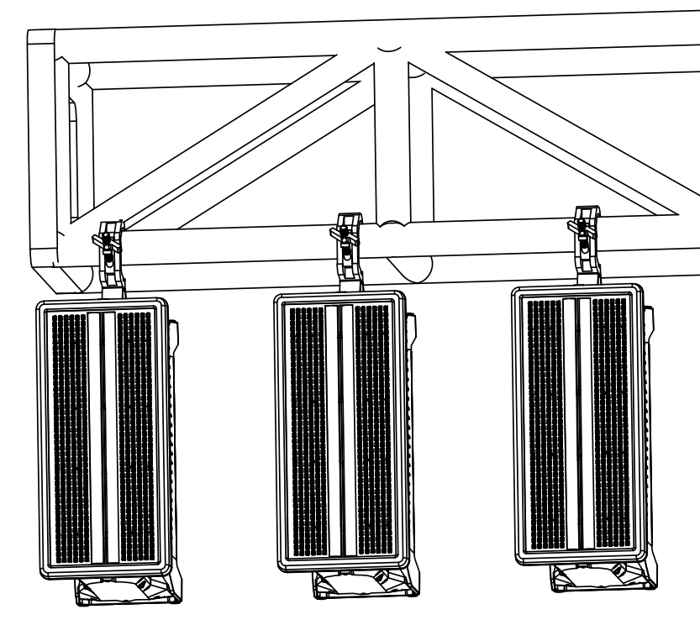
- If the luminaire is to be mounted on a truss or other structure, remove the floor stand/base and secure the luminaire to the supporting truss or other structure using the two quarter quick-lock brackets and suitable clamps supplied. Secure a safety cable (safety rope) between the support structure and the luminaire's attachment point.
- The safety cable (safety rope) must be able to support at least 10 times the weight of the luminaire.
- When using clamps for temporary installation, make sure quarter-turn fasteners are fully rotated and secured.
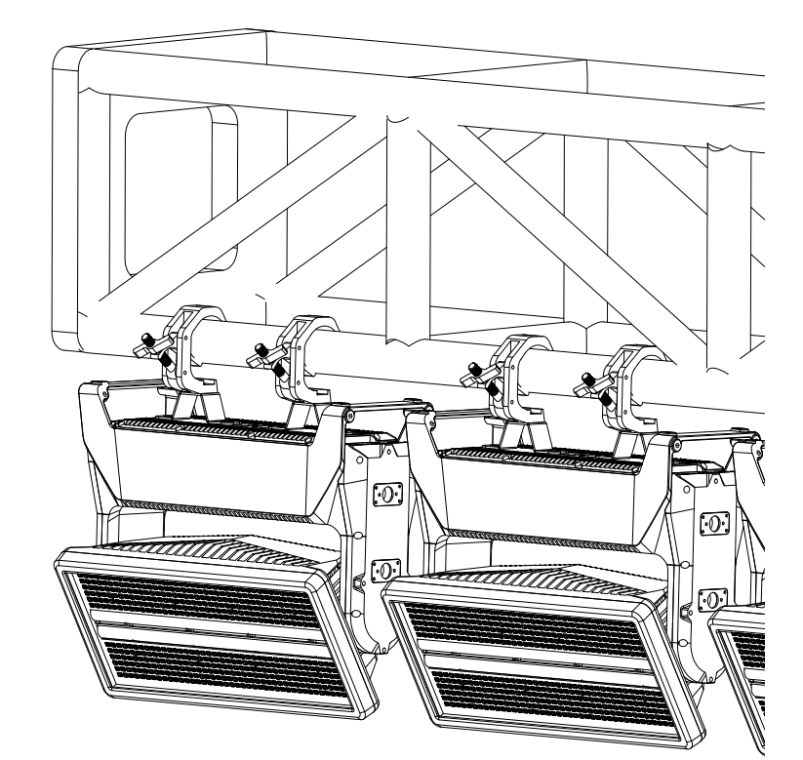

Wiring and conduit/sealing
- For permanent installations, have a qualified electrician connect the main cable directly to a suitable branch circuit. Ground connector for external use.
- Attached power and data cable luminaires are not intended for installation in permanently installed conduit or containment.
- When permanently installing the luminaire, ensure that the cable lead is installed as a service circuit into a suitable junction box and that a suitable cable clamp bushing/connector is used. Install cable leads as service circuits into appropriate junction boxes.
- All installed luminaires shall be securely mounted and the service circuits shall be adequately protected according to the location of the installation. All electrical wiring should be completed by a qualified electrician.
Fixture can be tilted 90 degrees - -90 degrees. It is also equipped with a zero position vertical lock.
Put the lamp head in zero position, vertical up, then you can push up to the lock head to open the vertical lock. Pressing the release button will automatically reset the limit lock.
Attention:
Please release the vertical lock before energising the lamp and check carefully. If you do not release the vertical lock, it may cause damage to the equipments.

Cable selection
- The fixtures can be operated on any 100-277 V, 50/60 Hz AC power source.
- Maximum peak power is 1500 W.
- When powered by AC110V. When powered by AC110V, the unit operates at full power with a maximum current of approximately 14 amps.
- When powered by AC220V. When powered by AC220V, the unit operates at full power with a maximum current of approximately 8 amps.
For permanent installation, have the power cable connected directly to a suitable branch circuit by a qualified electrician.
The terminal block must have an Intake Protection (IP) rating appropriate to the installation location.
It must be suitable for the installation location.
For temporary installations, an earth connector for outdoor use may be fitted to the mains cable.
When installing standard C-type circuit breakers:
Ensure that the number of luminaires connected through the same type of circuit breaker is not exceeded when the voltage is 220v.
Connect 2 luminaires through the same Type C 16A circuit breaker.
When the voltage is 110 volts, make sure that no more than
1 fixture through the same Type C 16A circuit breaker.
Do not use circuit breakers under 16A to act as front-end protection for the equipment, as frequent short-circuit protection may occur.
The fixture must be safely and effectively grounded and isolated from the AC power source. The AC power supply must contain a failsafe fuse or circuit breaker.

CAUTION: Do not open the power cord supplied with the luminaire or connect the luminaire to an electrical dimming system as this may damage the luminaire.

Identification and terminology
Illustrations may differ from the product received. Subject to change without notice.
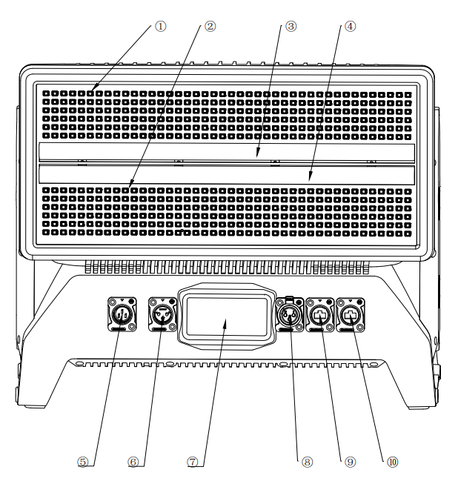
- RGB-A ② RGB-B ③ Tube-A
④ Tube-A ⑤ Power in ⑥ DMX-in
⑦ DMX-out ⑧ LCD touch panel ⑨ Artnet-A
⑩ Artnet-B

interactive interface recognition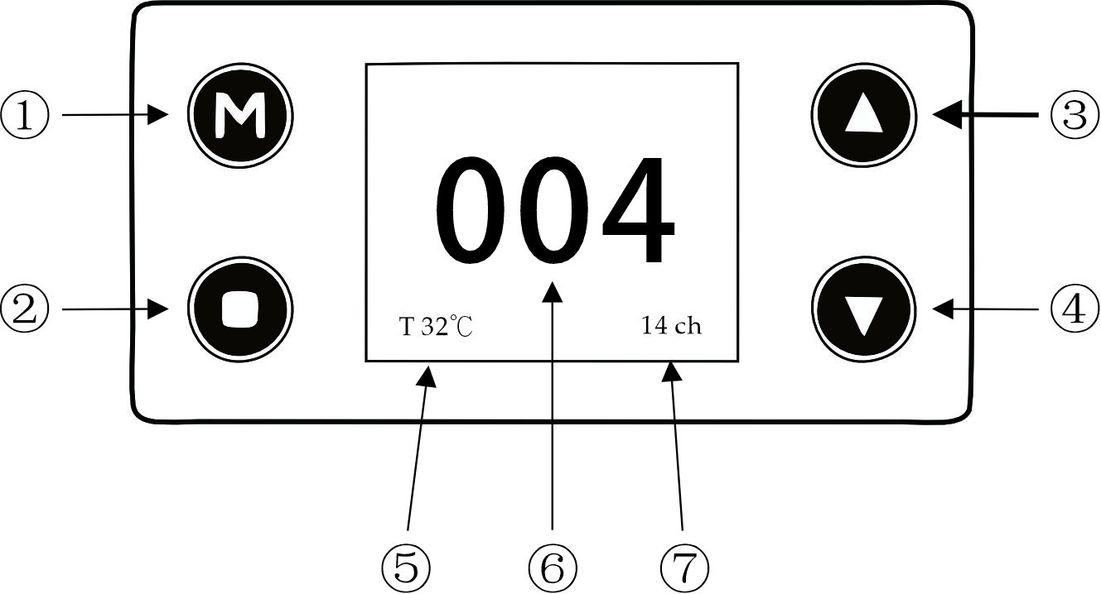
①MENU ②ENTER ③UP ④DOWN
⑤Temperature indication ⑥DMX-add ⑦Channel mode

Fault and error messages
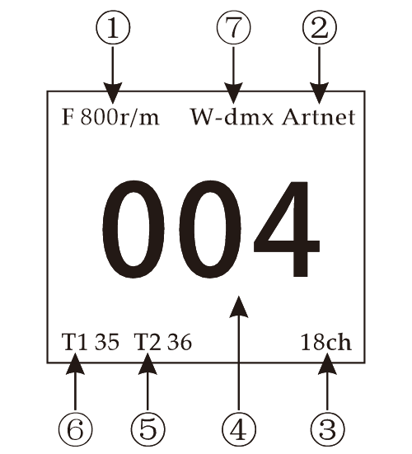

①FAN ②Art-net access ③Channel mode ④DMX-Add
⑤Tube-temp ⑥RGB-temp ⑦W-dmx access
- Prompts the current speed of the fan, and when it turns red, the cooling fan is faulty
- Network communication module access prompt. When it turns red, the component is faulty
- Current channel mode indication, when it turns red, drive train failure
- Prompts for current address code, when it turns red, DMX communication failure
- Indicates white substrate temperature, and when it turns red, the substrate temperature is abnormal.
- Prompts for RGB substrate temperature, when it turns red, the substrate temperature is abnormal
- Wireless DMX access prompt, turns red, wireless communication system failure

Configuration of lamps and lanterns

Use the control panel on the bottom of the fixture and the LCD display to set the fixture. Use the arrow buttons to navigate through the menus and options and the Enter button to select items. The options available for reference are listed in the ‘Control Menu’ on page 13. When power is applied, the display shows the currently selected operating mode and other information and the fixture's operating status.
Master/Slave Configuration
Use the ‘Mode→Auto 1/Auto 2/Auto 3/Auto 4’ menu to set your fixture as the master fixture, and the other fixtures will default to the slave fixtures.
Attention! One host fixture is allowed to exist under the unified circuit, otherwise it will affect the signal of the upper fixtures of the whole link.

To set the static colour manually
Using the ‘Mode→Adjustment’ menu, you can configure the fixtures to display predefined static colours (see ‘Control menu’ on page 13)
Using stand-alone operation
Stand-alone operation means that the fixtures are not connected to the control device, but call up the 4 pre-programmed programmes (Auto1/Auto2/Auto3/Auto4) inside the fixtures, which are played continuously in a cyclic manner with an adjustable running speed.

Connecting DMX Control Devices
If using a wired DMX system, connect the DMX input cable (with 3-pin male XLR plug) and the output cable (with 3-pin female XLR plug) to the DMX data chain and short the DMX output cable of the last luminaire in the data chain.
The DMX 512 is widely used in intelligent lighting control, where multiple luminaires can be connected together via the DMX 512 controller.
Please use the original DMX input cable.
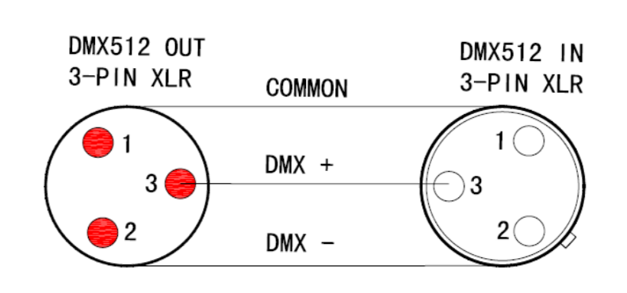
PIN 1：GND，
PIN 2：DATA-
PIN 3：DATA+

DMX Configuration
- This fixture can be run in six different DMX modes.
- Detailed commands for each mode are listed in the table in this document.
- The layout of channels 1-7 is the same in each mode.
- Refer to the User's Manual for details on pixel layouts in the fixture.
- Commands marked with an asterisk * in the table must start with a DMX value of zero and then send the DMX value continuously for 3 seconds (unless a different duration is specified).
- Fixtures can be controlled by signals sent by the DMX controller on multiple channels, the first channel used to receive data from the DMX control device is called the DMX start address. Each luminaire must have a DMX home address, if the luminaire has a DMX address of 10 and is in 4-channel DMX mode, then it will use channels 10, 11, 12 and 13.
- If two or more DMX luminaires of the same type have the same DMX address, they will mimic each other's behaviour. Incorrect settings will result in the lighting controller not responding effectively.
-- This fixture supports the RDM bi-directional communication protocol, which allows you to remotely rewrite the fixture address code, as well as adjust other functional options, view fixture operating temperatures, and modes from an RDM-enabled device or control device.
-- This luminaire supports ART-NET and Sacn communication protocols, which allows data transmission over a network cable.
- To change the address setting, press the up arrow to increase the address or the down arrow to decrease the setting. When the desired address is displayed, press Enter to save the setting.
- Using the DMX Mode menu on the control panel, specify the DMX mode that provides the desired fixture control and press Enter to confirm the selected mode.
- Use the interactive panel to change the IP address of the device and bind the output domain.

LED MAPS
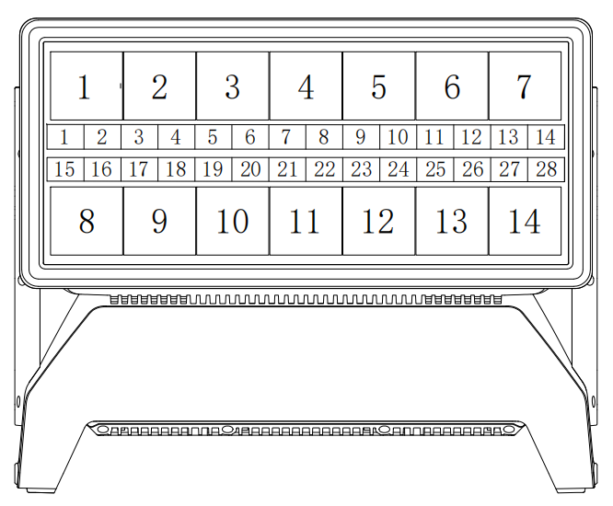

Important information！
1: Pixel arrangement can be changed through the interactive panel to change the layout
2: The arrangement of pixels can be changed quickly through special channels.

DIMMER CURVES

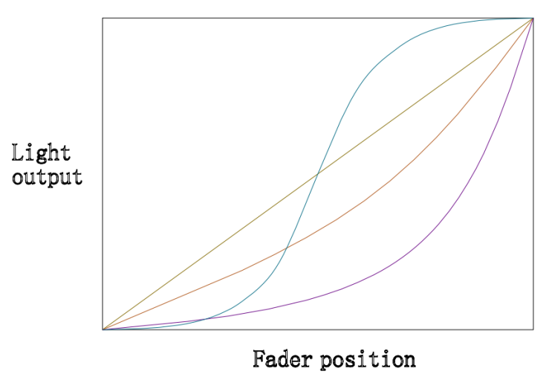
LINEAR
EXPONENTIAL
LOGARITHMIC
S-CURVE
The device is set up with 4 clock dimming curves that can be selected in total. The appropriate curve can be selected through the menu of the luminaire exchange panel, and the curves can be called up through the special channel in the luminaire channel.

Spectroscopy
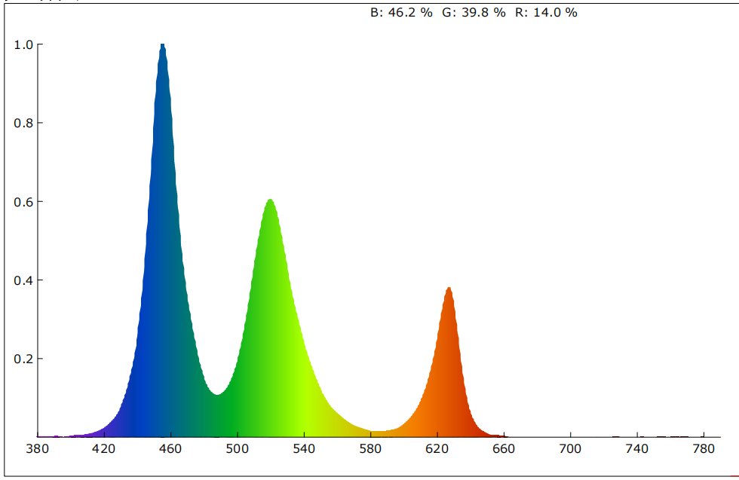

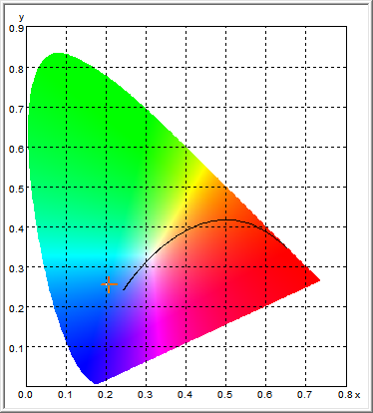
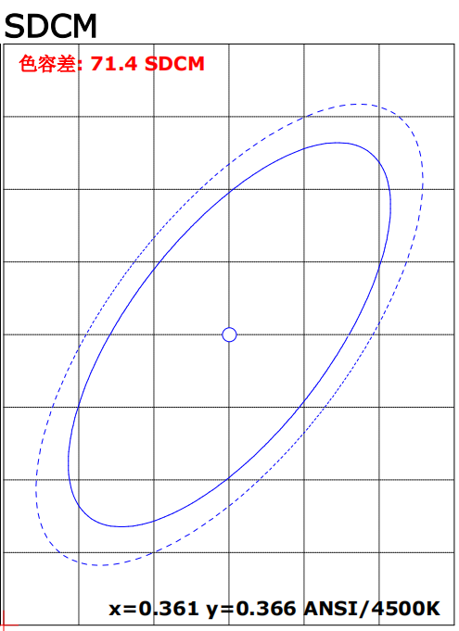
Colour parameters.
Illumination: 297029.875 lx
x: 0.2087 y: 0.2538 u: 0.1483
Coordinate v: 0.2706 Coordinate u‘: 0.1483 Coordinate v’: 0.4059
Peak wavelength: 455.4 nm Centre wavelength: 456.0 nm Main wavelength: 483.0 nm
Centre wavelength: 456.0 nm Main wavelength: 483.0 nm Centre wavelength: 507.6 nm Half width: 20.7 nm Dark signal: 5630.0
Peak signal: 52575.0 Colour tolerance: 71.4 Colour rendering index: 80.8
Colour Deviation: 0.2 Red Ratio: 14.0 % Green Ratio: 39.8 % Blue Ratio: 46.2 %
Irradiance: 122.4 mW/cm² Candlelight: 27502.8 fc Dark to light ratio: 4.0

Temperature vs

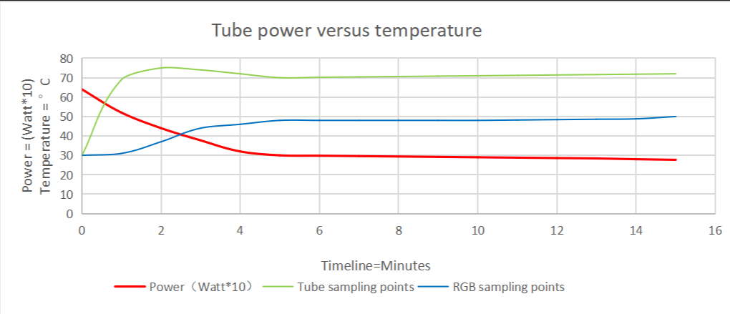

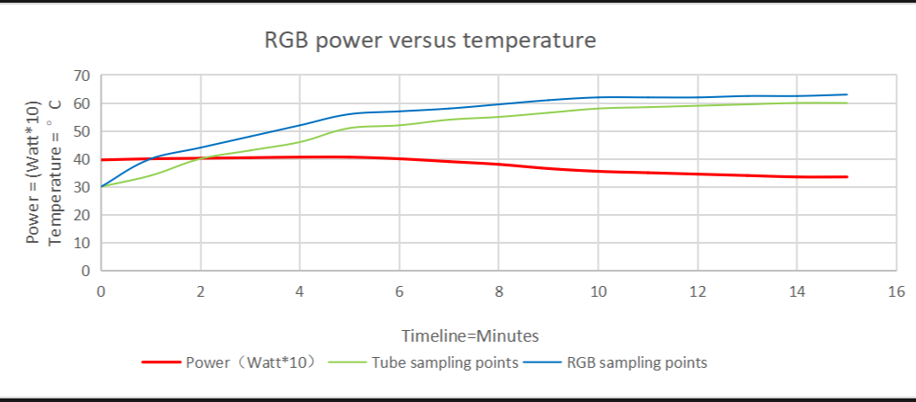

System menu
DMX Address | 0-512 |  | Default 001
DMX Channel | Channel | 8ch
DMX Channel | Channel | 18ch | default
DMX Channel | Channel | 25ch
DMX Channel | Channel | 95ch
Statuic | red | 0-255
Statuic | green | 0-255
Statuic | blue | 0-255
Statuic | white | 0-255
Statuic | Tilt | 0-255
Dimming curves | Closed |  | default
Dimming curves | Curves 1
Dimming curves | Curves 2
Dimming curves | Curves 3
Dimming curves | Curves 4
Ethemet Setting | IP Address | 2.0.0.10 | default
Ethemet Setting | Universe | 1 | default
Ethemet Setting | Subnet mask | 255.0.0.0 | default
Ethemet Setting | Protocol | Artnet
Ethemet Setting | Protocol | Sacn
Ethemet Setting | Protocol | DMX | default
System setting | Display Invert | yes
System setting | Display Invert | no | default
System setting | Tilt Offset | yes
System setting | Tilt Offset | no | default
System setting | Tilt Invert | yes
System setting | Tilt Invert | no | default
System setting | Backlight | 5S | default
System setting | Backlight | 10S
System setting | Backlight | 30S
System setting | Backlight | Always on
System setting | Backlight | Closed
System setting | Display Invert | yes
System setting | Display Invert | no | default
System setting | LED Array Swap | RGB Invert | Up Invert
System setting | LED Array Swap | RGB Invert | Down Invert
System setting | LED Array Swap | RGB Invert | UP-Down Swap
System setting | LED Array Swap | Tube Invert | Up Invert
System setting | LED Array Swap | Tube Invert | Down Invert
System setting | LED Array Swap | Tube Invert | UP-Down Swap
System setting | Fan seeting | Auto | default
System setting | Fan seeting | Low
System setting | Fan seeting | High
System setting | Key Backlight | Always on
System setting | Key Backlight | Auto | default
System setting | Key Backlight | Closed
System setting | Key Lock | yes | default
System setting | Key Lock | no
System setting | Signal hold | clear | default
System setting | Signal hold | hold
System setting | Testing | Test RGB
System setting | Testing | Test Tube
System setting | Factory Reset
System Infomation | Fixture Hours
System Infomation | Led Hours
System Infomation | DMX Add
System Infomation | DMX Ch
System Infomation | RDM UID
System Infomation | IP Add
System Infomation | Universe
System Infomation | RGB Temp
System Infomation | Tube Temp
System Infomation | Fan Speed
System Infomation | Tilt
System Infomation | Firmware version number

DMX-Charts
mode | function | value | percent
8ch
1 | Tilt | 0-255 | 0-100% | Tilt
2 | Dimmer | 0-255 | 0-100% | Dimmer
3 | beam | 0-255 | 0-100% | beam
4 | red | 0-255 | 0-100% | red
5 | green | 0-255 | 0-100% | green
6 | blue | 0-255 | 0-100% | blue
7 | RGB strobe | 0-255 | 0-100%
8 | Tube strobe | 0-255 | 0-100%
18ch
1 | Tilt | 0-255 | 0-100% | Tilt
2 | Dimmer | 0-255 | 0-100% | Dimmer
3 | beam dimmer | 0-255 | 0-100% | beam dimmer
4 | Tube strobe | 0-10 | 0.00%-3.92% | open
4 | Tube strobe | 11-36 | 4.31%-14.12% | closed
4 | Tube strobe | 37-40 | 14.51%-15.69% | Ramp up
4 | Tube strobe | 41-44 | 16.08%-17.25% | Ramp up, random
4 | Tube strobe | 45-48 | 17.65%-18.82% | Ramp down
4 | Tube strobe | 49-52 | 19.22%-20.39% | Ramp down, random
4 | Tube strobe | 53-56 | 20.78%-21.96% | Ramp up and down
4 | Tube strobe | 57-60 | 22.35%-23.53% | Ramp up and down, random
4 | Tube strobe | 61-64 | 23.92%-25.10% | Random white beam
4 | Tube strobe | 65-68 | 25.49%-26.67% | Random single pixel
4 | Tube strobe | 69-72 | 27.06%-28.24% | Lighting
4 | Tube strobe | 73-76 | 28.63%-29.80% | Spikers
4 | Tube strobe | 252-255 | 98.82%-100.00% | open
5 | strobe rate | 0-255 | 0-100% | strobe rate
6 | Tube FX | 0-255 | 0-100% | FX
7 | Tube FX speed | 0-255 | 0-100% | FX speed
8 | rgb dimmer | 0-255 | 0-100% | rgb dimmer
9 | red | 0-255 | 0-100% | red
10 | green | 0-255 | 0-100% | green
11 | blue | 0-255 | 0-100% | blue
12 | RGB strobe | 0-10 | 0.00%-3.92% | open
12 | RGB strobe | 11-36 | 4.31%-14.12% | closed
12 | RGB strobe | 37-40 | 14.51%-15.69% | Ramp up
12 | RGB strobe | 41-44 | 16.08%-17.25% | Ramp up, random
12 | RGB strobe | 45-48 | 17.65%-18.82% | Ramp down
12 | RGB strobe | 49-52 | 19.22%-20.39% | Ramp down, random
12 | RGB strobe | 53-56 | 20.78%-21.96% | Ramp up and down
12 | RGB strobe | 57-60 | 22.35%-23.53% | Ramp up and down, random
12 | RGB strobe | 61-64 | 23.92%-25.10% | Random white beam
12 | RGB strobe | 65-68 | 25.49%-26.67% | Random single pixel
12 | RGB strobe | 69-72 | 27.06%-28.24% | Lighting
12 | RGB strobe | 73-76 | 28.63%-29.80% | Spikers
12 | RGB strobe | 252-255 | 98.82%-100.00% | open
13 | RGB strobe rate | 0-255 | 0-100% | strobe rate
14 | RGB FX | 0-255 | 0-100% | FX
15 | RGB FX rate | 0-255 | 0-100% | FX speed
16 | RUG macro color | 0-10 | 0-3.92% | closed
16 | RUG macro color | 11-250 | 4.31%-98.03% | R-G-B-RGB
16 | RUG macro color | 251-255 | 98.43%-100% | WHITE(RGB all)
17 | RUG macro fade | 0-255 | 0-100% | duration
18 | Special/control | 0-5 | 0.00%-1.96% | No fuction
18 | Special/control | 6-10 | 2.35%-3.92% | Dimmer speed 0
18 | Special/control | 11-15 | 4.31%-5.88% | Dimmer speed 1
18 | Special/control | 16-20 | 6.27%-7.84% | Dimmer speed 2
18 | Special/control | 21-25 | 8.24%-9.80% | Dimmer speed 3
18 | Special/control | 56-60 | 21.96%-23.53% | Fan mode auto
18 | Special/control | 61-65 | 23.92%-25.49% | Fan mode high
18 | Special/control | 66-70 | 25.88%-27.45% | Tilt reset
18 | Special/control | 71-75 | 27.84%-29.41% | Plate1 invert off
18 | Special/control | 76-80 | 29.80%-31.37% | Plate1 invert on
18 | Special/control | 81-85 | 31.76%-33.33% | Plate2 invert off
18 | Special/control | 86-90 | 33.73%-35.29% | Plate2 invert on
18 | Special/control | 91-95 | 35.69%-37.25% | Beam1 invert off
18 | Special/control | 96-100 | 37.65%-39.22% | Beam1 invert on
18 | Special/control | 101-105 | 39.61%-41.18% | Beam2 invert off
18 | Special/control | 106-110 | 41.57%-43.14% | Beam2 invert on
18 | Special/control | 111-115 | 43.53%-45.10% | Plate swap on
18 | Special/control | 116-120 | 45.49%-47.06% | Plate swap off
18 | Special/control | 121-125 | 47.45%-49.02% | Beam swap on
18 | Special/control | 126-130 | 49.41%-50.98% | Beam swap off
18 | Special/control | 131-140 | 51.37%-54.90% | Ever Bright
18 | Special/control | 141-150 | 55.29%-58.82% | Close in 10s
18 | Special/control | 151-155 | 59.22%-60.78% | Close in 60s
18 | Special/control | 156-160 | 61.18%-62.75% | Factory data reset
18 | Special/control | 176-255 | 69.02%-100.00% | No function
25ch
1 | Tilt | 0-255 | 0-100% | Tilt
2 | Dimmer | 0-255 | 0-100% | Dimmer
3 | beam dimmer | 0-255 | 0-100% | beam dimmer
4 | Tube strobe | 0-10 | 0.00%-3.92% | open
4 | Tube strobe | 11-36 | 4.31%-14.12% | closed
4 | Tube strobe | 37-40 | 14.51%-15.69% | Ramp up
4 | Tube strobe | 41-44 | 16.08%-17.25% | Ramp up, random
4 | Tube strobe | 45-48 | 17.65%-18.82% | Ramp down
4 | Tube strobe | 49-52 | 19.22%-20.39% | Ramp down, random
4 | Tube strobe | 53-56 | 20.78%-21.96% | Ramp up and down
4 | Tube strobe | 57-60 | 22.35%-23.53% | Ramp up and down, random
4 | Tube strobe | 61-64 | 23.92%-25.10% | Random white beam
4 | Tube strobe | 65-68 | 25.49%-26.67% | Random single pixel
4 | Tube strobe | 69-72 | 27.06%-28.24% | Lighting
4 | Tube strobe | 73-76 | 28.63%-29.80% | Spikers
4 | Tube strobe | 252-255 | 98.82%-100.00% | open
5 | Tube strobe rate | 0-255 | 0-100%
6 | Tube duration | 0-255 | 0-100% | 0-750hm
7 | Tube FX |  | ?
8 | Tube FX rate | 0-255 | 0-100%
9 | Tube FX fade | 0-255 | 0-100%
10 | RGB dimmer | 0-255 | 0-100%
11 | red | 0-255 | 0-100% | red
12 | green | 0-255 | 0-100% | green
13 | blue | 0-255 | 0-100% | blue
14 | RGB strobe | 0-10 | 0.00%-3.92% | open
14 | RGB strobe | 11-36 | 4.31%-14.12% | closed
14 | RGB strobe | 37-40 | 14.51%-15.69% | Ramp up
14 | RGB strobe | 45-48 | 17.65%-18.82% | Ramp down
14 | RGB strobe | 53-56 | 20.78%-21.96% | Ramp up and down
14 | RGB strobe | 65-68 | 25.49%-26.67% | Random
14 | RGB strobe | 69-72 | 27.06%-28.24% | Lighting
14 | RGB strobe | 73-76 | 28.63%-29.80% | Spikers
14 | RGB strobe | 252-255 | 98.82%-100.00% | open
15 | RGB strobe rate | 0-255 | 0-100%
16 | RGB duration | 0-255 | 0-100% | 0-750hm
17 | RGB FX | 0-255 | 0-100%
18 | RGB FX rate | 0-255 | 0-100%
19 | RGB FX color | 0-10 | 0-3.92% | closed
19 | RGB FX color | 11-250 | 4.31%-98.03% | R-G-B-RGB
19 | RGB FX color | 251-255 | 98.43%-100% | WHITE
20 | RGB FX fade
21 | Backligh dimmer
22 | Backligh-Red | 0-255 | 0-100%
23 | Backligh-Green | 0-255 | 0-100%
24 | Backligh-Blue | 0-255 | 0-100%
25 | Special/control | 0-5 | 0.00%-1.96% | No fuction
25 | Special/control | 6-10 | 2.35%-3.92% | Dimmer speed 0
25 | Special/control | 11-15 | 4.31%-5.88% | Dimmer speed 1
25 | Special/control | 16-20 | 6.27%-7.84% | Dimmer speed 2
25 | Special/control | 21-25 | 8.24%-9.80% | Dimmer speed 3
25 | Special/control | 56-60 | 21.96%-23.53% | Fan mode auto
25 | Special/control | 61-65 | 23.92%-25.49% | Fan mode high
25 | Special/control | 66-70 | 25.88%-27.45% | Tilt reset
25 | Special/control | 71-75 | 27.84%-29.41% | Plate1 invert off
25 | Special/control | 76-80 | 29.80%-31.37% | Plate1 invert on
25 | Special/control | 81-85 | 31.76%-33.33% | Plate2 invert off
25 | Special/control | 86-90 | 33.73%-35.29% | Plate2 invert on
25 | Special/control | 91-95 | 35.69%-37.25% | Beam1 invert off
25 | Special/control | 96-100 | 37.65%-39.22% | Beam1 invert on
25 | Special/control | 101-105 | 39.61%-41.18% | Beam2 invert off
25 | Special/control | 106-110 | 41.57%-43.14% | Beam2 invert on
25 | Special/control | 111-115 | 43.53%-45.10% | Plate swap on
25 | Special/control | 116-120 | 45.49%-47.06% | Plate swap off
25 | Special/control | 121-125 | 47.45%-49.02% | Beam swap on
25 | Special/control | 126-130 | 49.41%-50.98% | Beam swap off
25 | Special/control | 131-140 | 51.37%-54.90% | Ever Bright
25 | Special/control | 141-150 | 55.29%-58.82% | Close in 10s
25 | Special/control | 151-155 | 59.22%-60.78% | Close in 60s
25 | Special/control | 176-255 | 69.02%-100.00% | No function
95ch | 扩展模式
1 | Tilt | 0-255 | 0-100% | Tilt
2 | Dimmer | 0-255 | 0-100% | Dimmer
3 | beam dimmer | 0-255 | 0-100% | beam dimmer
4 | Tube strobe | 0-10 | 0.00%-3.92% | open
4 | Tube strobe | 11-36 | 4.31%-14.12% | closed
4 | Tube strobe | 37-40 | 14.51%-15.69% | Ramp up
4 | Tube strobe | 41-44 | 16.08%-17.25% | Ramp up, random
4 | Tube strobe | 45-48 | 17.65%-18.82% | Ramp down
4 | Tube strobe | 49-52 | 19.22%-20.39% | Ramp down, random
4 | Tube strobe | 53-56 | 20.78%-21.96% | Ramp up and down
4 | Tube strobe | 57-60 | 22.35%-23.53% | Ramp up and down, random
4 | Tube strobe | 61-64 | 23.92%-25.10% | Random white beam
4 | Tube strobe | 65-68 | 25.49%-26.67% | Random single pixel
4 | Tube strobe | 69-72 | 27.06%-28.24% | Lighting
4 | Tube strobe | 73-76 | 28.63%-29.80% | Spikers
4 | Tube strobe | 252-255 | 98.82%-100.00% | open
5 | Tube strobe rate | 0-255 | 0-100% | strobe rate
6 | Tube duration | 0-255 | 0-100% | strobe duration
7 | Tube FX | 0-255 | 0-100%
8 | Tube FX rate | 0-255 | 0-100%
9 | Tube FX fade | 0-255 | 0-100% | FX duration
10 | RGB dimmer | 0-255 | 0-100% | rgb dimmer
11 | red | 0-255 | 0-100% | red
12 | green | 0-255 | 0-100% | green
13 | blue | 0-255 | 0-100% | blue
14 | RGB strobe | 0-10 | 0.00%-3.92% | open
14 | RGB strobe | 11-36 | 4.31%-14.12% | closed
14 | RGB strobe | 37-40 | 14.51%-15.69% | Ramp up
14 | RGB strobe | 41-44 | 16.08%-17.25% | Ramp up, random
14 | RGB strobe | 45-48 | 17.65%-18.82% | Ramp down
14 | RGB strobe | 49-52 | 19.22%-20.39% | Ramp down, random
14 | RGB strobe | 53-56 | 20.78%-21.96% | Ramp up and down
14 | RGB strobe | 57-60 | 22.35%-23.53% | Ramp up and down, random
14 | RGB strobe | 61-64 | 23.92%-25.10% | Random white beam
14 | RGB strobe | 65-68 | 25.49%-26.67% | Random single pixel
14 | RGB strobe | 69-72 | 27.06%-28.24% | Lighting
14 | RGB strobe | 73-76 | 28.63%-29.80% | Spikers
14 | RGB strobe | 252-255 | 98.82%-100.00% | open
15 | RGB strobe rate | 0-255 | 0-100%
16 | RGB duration | 0-255 | 0-100%
17 | RGB FX | 0-255 | 0-100%
18 | RGB FX rate | 0-255 | 0-100%
19 | RGB FX color | 0-10 | 0-3.92% | closed
19 | RGB FX color | 11-250 | 4.31%-98.03% | R-G-B-RGB
19 | RGB FX color | 251-255 | 98.43%-100% | WHITE
20 | RGB FX fade | 0-255 | 0-100%
21 | Backligh dimmer | 0-255 | 0-100%
22 | Backligh-Red | 0-255 | 0-100%
23 | Backligh-Green | 0-255 | 0-100%
24 | Backligh-Blue | 0-255 | 0-100%
25 | Special/control | 0-5 | 0.00%-1.96% | No fuction
25 | Special/control | 6-10 | 2.35%-3.92% | Dimmer speed 0
25 | Special/control | 11-15 | 4.31%-5.88% | Dimmer speed 1
25 | Special/control | 16-20 | 6.27%-7.84% | Dimmer speed 2
25 | Special/control | 21-25 | 8.24%-9.80% | Dimmer speed 3
25 | Special/control | 56-60 | 21.96%-23.53% | Fan mode auto
25 | Special/control | 61-65 | 23.92%-25.49% | Fan mode high
25 | Special/control | 66-70 | 25.88%-27.45% | Tilt reset
25 | Special/control | 71-75 | 27.84%-29.41% | Plate1 invert off
25 | Special/control | 76-80 | 29.80%-31.37% | Plate1 invert on
25 | Special/control | 81-85 | 31.76%-33.33% | Plate2 invert off
25 | Special/control | 86-90 | 33.73%-35.29% | Plate2 invert on
25 | Special/control | 91-95 | 35.69%-37.25% | Beam1 invert off
25 | Special/control | 96-100 | 37.65%-39.22% | Beam1 invert on
25 | Special/control | 101-105 | 39.61%-41.18% | Beam2 invert off
25 | Special/control | 106-110 | 41.57%-43.14% | Beam2 invert on
25 | Special/control | 111-115 | 43.53%-45.10% | Plate swap on
25 | Special/control | 116-120 | 45.49%-47.06% | Plate swap off
25 | Special/control | 121-125 | 47.45%-49.02% | Beam swap on
25 | Special/control | 126-130 | 49.41%-50.98% | Beam swap off
25 | Special/control | 131-140 | 51.37%-54.90% | Ever Bright
25 | Special/control | 141-150 | 55.29%-58.82% | Close in 10s
25 | Special/control | 151-155 | 59.22%-60.78% | Close in 60s
25 | Special/control | 176-255 | 69.02%-100.00% | No function
26 | Plate Pixel 1 Red | 0-255 | 0-100%
27 | Plate Pixel 1 Green | 0-255 | 0-100%
28 | Plate Pixel 1 Blue | 0-255 | 0-100%
29 | Plate Pixel 2 Red | 0-255 | 0-100%
30 | Plate Pixel 2 Green | 0-255 | 0-100%
31 | Plate Pixel 2 Blue | 0-255 | 0-100%
32 | Plate Pixel 3 Red | 0-255 | 0-100%
33 | Plate Pixel 3 Green | 0-255 | 0-100%
34 | Plate Pixel 3 Blue | 0-255 | 0-100%
35 | Plate Pixel 4 Red | 0-255 | 0-100%
36 | Plate Pixel 4 Green | 0-255 | 0-100%
37 | Plate Pixel 4 Blue | 0-255 | 0-100%
38 | Plate Pixel 5 Red | 0-255 | 0-100%
39 | Plate Pixel 5 Green | 0-255 | 0-100%
40 | Plate Pixel 5 Blue | 0-255 | 0-100%
41 | Plate Pixel 6 Red | 0-255 | 0-100%
42 | Plate Pixel 6 Green | 0-255 | 0-100%
43 | Plate Pixel 6 Blue | 0-255 | 0-100%
44 | Plate Pixel 7 Red | 0-255 | 0-100%
45 | Plate Pixel 7 Green | 0-255 | 0-100%
46 | Plate Pixel 7 Blue | 0-255 | 0-100%
47 | Plate Pixel 8 Red | 0-255 | 0-100%
48 | Plate Pixel 8 Green | 0-255 | 0-100%
49 | Plate Pixel 8 Blue | 0-255 | 0-100%
50 | Plate Pixel 9 Red | 0-255 | 0-100%
51 | Plate Pixel 9 Green | 0-255 | 0-100%
52 | Plate Pixel 9 Blue | 0-255 | 0-100%
53 | Plate Pixel 10 Red | 0-255 | 0-100%
54 | Plate Pixel 10 Green | 0-255 | 0-100%
55 | Plate Pixel 10 Blue | 0-255 | 0-100%
56 | Plate Pixel 11 Red | 0-255 | 0-100%
57 | Plate Pixel 11 Green | 0-255 | 0-100%
58 | Plate Pixel 11 Blue | 0-255 | 0-100%
59 | Plate Pixel 12 Red | 0-255 | 0-100%
60 | Plate Pixel 12 Green | 0-255 | 0-100%
61 | Plate Pixel 12 Blue | 0-255 | 0-100%
62 | Plate Pixel 13 Red | 0-255 | 0-100%
63 | Plate Pixel 13 Green | 0-255 | 0-100%
64 | Plate Pixel 13 Blue | 0-255 | 0-100%
65 | Plate Pixel 14 Red | 0-255 | 0-100%
66 | Plate Pixel 14 Green | 0-255 | 0-100%
67 | Plate Pixel 14 Blue | 0-255 | 0-100%
68 | Beam Pixel 1 | 0-255 | 0-100%
69 | Beam Pixel 2 | 0-255 | 0-100%
70 | Beam Pixel 3 | 0-255 | 0-100%
71 | Beam Pixel 4 | 0-255 | 0-100%
72 | Beam Pixel 5 | 0-255 | 0-100%
73 | Beam Pixel 6 | 0-255 | 0-100%
74 | Beam Pixel 7 | 0-255 | 0-100%
75 | Beam Pixel 8 | 0-255 | 0-100%
76 | Beam Pixel 9 | 0-255 | 0-100%
77 | Beam Pixel 10 | 0-255 | 0-100%
78 | Beam Pixel 11 | 0-255 | 0-100%
79 | Beam Pixel 12 | 0-255 | 0-100%
80 | Beam Pixel 13 | 0-255 | 0-100%
81 | Beam Pixel 14 | 0-255 | 0-100%
82 | Beam Pixel 15 | 0-255 | 0-100%
83 | Beam Pixel 16 | 0-255 | 0-100%
84 | Beam Pixel 17 | 0-255 | 0-100%
85 | Beam Pixel 18 | 0-255 | 0-100%
86 | Beam Pixel 19 | 0-255 | 0-100%
87 | Beam Pixel 20 | 0-255 | 0-100%
88 | Beam Pixel 21 | 0-255 | 0-100%
89 | Beam Pixel 22 | 0-255 | 0-100%
90 | Beam Pixel 23 | 0-255 | 0-100%
91 | Beam Pixel 24 | 0-255 | 0-100%
92 | Beam Pixel 25 | 0-255 | 0-100%
93 | Beam Pixel 26 | 0-255 | 0-100%
94 | Beam Pixel 27 | 0-255 | 0-100%
95 | Beam Pixel 28 | 0-255 | 0-100%

Cleaning & Maintenance
- To maintain optimum performance, regular cleaning is essential.
- Depending on the operating environment, the cleaning schedule may vary.
- Check frequently during the first few weeks of operation to see if cleaning is required.
- Evaluate cleaning requirements on a case-by-case basis.
- Clean the fixture with a soft cloth moistened with a solution of water and mild detergent.
- Clean the fixture. Do not use products containing solvents, abrasives, or caustic substances for cleaning, as they
may damage hardware, cables, and connectors.

Maintenance records
dates | fault description | Maintenance content | maintenance personnel | memo

广州铭亮灯光音响设备有限公司
Guangzhou Ming Light Lighting And Sound Equipment Co..Ltd
香港铭亮舞台灯光实业有限公司
COLORFUL LIGHT(HK)LIMITED

www.colorfullight.cn
售后服务：13659993938
销售专员：18218356183
24小时服务热线：020-86024035

本手册适用范围S2000 v1.0固件及以上版本

