Mini-Storm

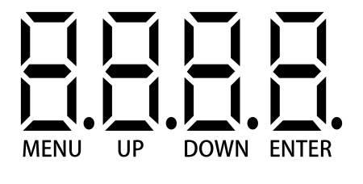

一：Operation manu
Addr | A001-A512 | Addr A001-A512
Chnd | CH23 | CH101 | Channel selection
Slnd | Mast | Master
Slnd | d512 | Slave
Slnd | FLS | Fast lighting show
SHOU | ON | Hold | Sound lost
SHOU | Off | Back out | Sound lost
Soun | Su | 0--20 | Sound action
Soun | Se | 0--99 | Sound sensitivity
Auto | Au | 0--20 | Auto action
Auto | Sp | 0-9 | Auto
RF | ON | RF433-On | Master
RF | OFF | RF433-Off
dISP | dISP | Display reverse
Ver | V10 | Version
Load | NO | No
Load | YES | Reset | Factory reset

2. Channel

23-ch | Function | Value | Description
1 | Beam-Total dimmer | 000--255 | Beam-Total dimmer 0%~ 100%
2 | Beam-Strobe | 000--255 | 0%~ 100%
3 | 5050 White-Total dimmer | 000--255 | 0%~ 100%
4 | 5050 White- Strobe | 000--255 | 0%~ 100%
5 | 5050RGB- Total dimmer | 000--255 | 0%~ 100%
6 | 5050RGB- Strobe | 000--255 | 0%~ 100%
7 | Beam-dimmer | 000--255 | Red 0%~ 100%
8 | Beam-dimmer | 000--255 | Green 0%~ 100%
9 | Beam-dimmer | 000--255 | Blue 0%~ 100%
10 | Beam-dimmer | 000--255 | White 0%~ 100%
11 | 5050 White-dimmer | 000--255 | 0%~ 100%
12 | 5050RGB-Red dimmer | 000--255 | 0%~ 100%
13 | 5050RGB-Green dimmer | 000--255 | 0%~ 100%
14 | 5050RGB-Green dimmer | 000--255 | 0%~ 100%
15 | Laser-Red | 000--007 | No function
15 | Laser-Red | 008--255 | On
16 | Laser-Green | 000--007 | No function
16 | Laser-Green | 008--255 | On
17 | Laser | 000--009 | No function
17 | Laser Motor | 010--134 | Rotate counterclockwise from fast to slow
17 | Laser Motor | 135--245 | Rotate clockwise from slow to fast
17 | Laser | 246--255 | Stop turning
18 | 5050RGB | 000-007 | No function
18 | 5050RGB | 008--247 | Program (Annex 1 for details)
18 | 5050RGB | 248--255 | Sound control
19 | 5050RGB | 000--255 | Program speed 0%~ 100%
20 | 5050White | 000-007 | No function
20 | 5050White | 008--247 | Program (Annex 1 for details)
20 | 5050White | 248--255 | Sound control
21 | 5050White | 000--255 | Program speed 0%~ 100%
22 | Beam | 000-007 | No function
22 | Beam | 008--247 | Program (Annex 1 for details)
22 | Beam-Sound control | 248--255
23 | Beam | 000--255 | Program speed 0%~ 100%

101-ch | Function | Value | Description
1 | Beam-Total dimmer | 000--255 | 0%~ 100%
2 | Beam-Strobe | 000--255 | 0%~ 100%
3 | Beam1-Red dimmer | 000--255 | 0%~ 100%
4 | Beam1-Green dimmer | 000--255 | 0%~ 100%
5 | Beam1-Green dimmer | 000--255 | 0%~ 100%
6 | Beam1-White dimmer | 000--255 | 0%~ 100%
7 | Beam2-Red dimmer | 000--255 | 0%~ 100%
8 | Beam2-Green dimmer | 000--255 | 0%~ 100%
9 | Beam2-Green dimmer | 000--255 | 0%~ 100%
10 | Beam2-White dimmer | 000--255 | 0%~ 100%
11 | 5050White-Total dimmer | 000--255 | 0%~ 100%
12 | 5050White-Strobe | 000--255 | 0%~ 100%
13 | 5050White1-Dimmer | 000--255 | 0%~ 100%
14 | 5050White2-Dimmer | 000--255 | 0%~ 100%
15 | 5050White3-Dimmer | 000--255 | 0%~ 100%
16 | 5050White4-Dimmer | 000--255 | 0%~ 100%
17 | 5050White5-Dimmer | 000--255 | 0%~ 100%
18 | 5050White6-Dimmer | 000--255 | 0%~ 100%
19 | 5050 RGB-Total dimmer | 000--255 | 0%~ 100%
20 | 5050 RGB-Strobe | 000--255 | 0%~ 100%
21 | 5050RGB-1-Red dimmer | 000--255 | 0%~ 100%
22 | 5050RGB-1-Green dimmer | 000--255 | 0%~ 100%
23 | 5050RGB-1-Green dimmer | 000--255 | 0%~ 100%
24 | 5050RGB-2-Red dimmer | 000--255 | 0%~ 100%
25 | 5050RGB-2-Green dimmer | 000--255 | 0%~ 100%
26 | 5050RGB-2-Green dimmer | 000--255 | 0%~ 100%
27 | 5050RGB-3-Red dimmer | 000--255 | 0%~ 100%
28 | 5050RGB-3-Green dimmer | 000--255 | 0%~ 100%
29 | 5050RGB-3-Green dimmer | 000--255 | 0%~ 100%
30 | 5050RGB-4-Red dimmer | 000--255 | 0%~ 100%
31 | 5050RGB-4-Green dimmer | 000--255 | 0%~ 100%
32 | 5050RGB-4-Green dimmer | 000--255 | 0%~ 100%
33 | 5050RGB-5-Red dimmer | 000--255 | 0%~ 100%
34 | 5050RGB-5-Green dimmer | 000--255 | 0%~ 100%
35 | 5050RGB-5-Green dimmer | 000--255 | 0%~ 100%
36 | 5050RGB-6-Red dimmer | 000--255 | 0%~ 100%
37 | 5050RGB-6-Green dimmer | 000--255 | 0%~ 100%
38 | 5050RGB-6-Green dimmer | 000--255 | 0%~ 100%
39 | 5050RGB-7-Red dimmer | 000--255 | 0%~ 100%
40 | 5050RGB-7-Green dimmer | 000--255 | 0%~ 100%
41 | 5050RGB-7-Green dimmer | 000--255 | 0%~ 100%
42 | 5050RGB-8-Red dimmer | 000--255 | 0%~ 100%
43 | 5050RGB-8-Green dimmer | 000--255 | 0%~ 100%
44 | 5050RGB-8-Green dimmer | 000--255 | 0%~ 100%
45 | 5050RGB-9-Red dimmer | 000--255 | 0%~ 100%
46 | 5050RGB-9-Green dimmer | 000--255 | 0%~ 100%
47 | 5050RGB-9-Green dimmer | 000--255 | 0%~ 100%
48 | 5050RGB-10-Red dimmer | 000--255 | 0%~ 100%
49 | 5050RGB-10-Green dimmer | 000--255 | 0%~ 100%
50 | 5050RGB-10-Green dimmer | 000--255 | 0%~ 100%
51 | 5050RGB-11-Red dimmer | 000--255 | 0%~ 100%
52 | 5050RGB-11-Green dimmer | 000--255 | 0%~ 100%
53 | 5050RGB-11-Green dimmer | 000--255 | 0%~ 100%
54 | 5050RGB-12-Red dimmer | 000--255 | 0%~ 100%
55 | 5050RGB-12-Green dimmer | 000--255 | 0%~ 100%
56 | 5050RGB-12-Green dimmer | 000--255 | 0%~ 100%
57 | 5050RGB-13-Red dimmer | 000--255 | 0%~ 100%
58 | 5050RGB-13-Green dimmer | 000--255 | 0%~ 100%
59 | 5050RGB-13-Green dimmer | 000--255 | 0%~ 100%
60 | 5050RGB-14-Red dimmer | 000--255 | 0%~ 100%
61 | 5050RGB-14-Green dimmer | 000--255 | 0%~ 100%
62 | 5050RGB-14-Green dimmer | 000--255 | 0%~ 100%
63 | 5050RGB-15-Red dimmer | 000--255 | 0%~ 100%
64 | 5050RGB-15-Green dimmer | 000--255 | 0%~ 100%
65 | 5050RGB-15-Green dimmer | 000--255 | 0%~ 100%
66 | 5050RGB-16-Red dimmer | 000--255 | 0%~ 100%
67 | 5050RGB-16-Green dimmer | 000--255 | 0%~ 100%
68 | 5050RGB-16-Green dimmer | 000--255 | 0%~ 100%
69 | 5050RGB-17-Red dimmer | 000--255 | 0%~ 100%
70 | 5050RGB-17-Green dimmer | 000--255 | 0%~ 100%
71 | 5050RGB-17-Green dimmer | 000--255 | 0%~ 100%
72 | 5050RGB-18-Red dimmer | 000--255 | 0%~ 100%
73 | 5050RGB-18-Green dimmer | 000--255 | 0%~ 100%
74 | 5050RGB-18-Green dimmer | 000--255 | 0%~ 100%
75 | 5050RGB-19-Red dimmer | 000--255 | 0%~ 100%
76 | 5050RGB-19-Green dimmer | 000--255 | 0%~ 100%
77 | 5050RGB-19-Green dimmer | 000--255 | 0%~ 100%
78 | 5050RGB-20-Red dimmer | 000--255 | 0%~ 100%
79 | 5050RGB-20-Green dimmer | 000--255 | 0%~ 100%
80 | 5050RGB-20-Green dimmer | 000--255 | 0%~ 100%
81 | 5050RGB-21-Red dimmer | 000--255 | 0%~ 100%
82 | 5050RGB-21-Green dimmer | 000--255 | 0%~ 100%
83 | 5050RGB-21-Green dimmer | 000--255 | 0%~ 100%
84 | 5050RGB-22-Red dimmer | 000--255 | 0%~ 100%
85 | 5050RGB-22-Green dimmer | 000--255 | 0%~ 100%
86 | 5050RGB-22-Green dimmer | 000--255 | 0%~ 100%
87 | 5050RGB-23-Red dimmer | 000--255 | 0%~ 100%
88 | 5050RGB-23-Green dimmer | 000--255 | 0%~ 100%
89 | 5050RGB-23-Green dimmer | 000--255 | 0%~ 100%
90 | 5050RGB-24-Red dimmer | 000--255 | 0%~ 100%
91 | 5050RGB-24-Green dimmer | 000--255 | 0%~ 100%
92 | 5050RGB-24-Green dimmer | 000--255 | 0%~ 100%
93 | Laser-Red | 000--007 | No function
93 | Laser-Red | 008--255 | On
94 | Laser-Green | 000--007 | No function
94 | Laser-Green | 008--255 | On
95 | Laser | 000--009 | No function
95 | Laser motor | 010--134 | Rotate counterclockwise from fast to slow
95 | Laser motor | 135--245 | Rotate clockwise from slow to fast
95 | Laser | 246--255 | Stop turning
96 | 5050RGB | 000-007 | No function
96 | 5050RGB | 008--247 | Program (Annex 1 for details)
96 | 5050RGB | 248--255 | Sound control
97 | 5050RGB | 000--255 | Program speed 0%~ 100%
98 | 5050White | 000-007 | No function
98 | 5050White | 008--247 | Program (Annex 1 for details)
98 | 5050White | 248--255 | Sound control
99 | 5050White | 000--255 | Program speed 0%~ 100%
100 | Beam | 000-007 | No function
100 | Beam | 008--247 | Program (Annex 1 for details)
100 | Beam | 248--255 | Sound control
101 | Beam | 000--255 | Program speed 0%~ 100%

Channel Value specification（Annex I）
Program value
000--007 | No program
008--019 | Pro1
020--031 | Pro2
032--043 | Pro3
044--055 | Pro4
056--067 | Pro5
068--079 | Pro6
080--091 | Pro7
092--103 | Pro8
104--115 | Pro9
116--127 | Pro10
128--139 | Pro11
140--151 | Pro12
152--163 | Pro13
164--175 | Pro14
176--187 | Pro15
188--199 | Pro16
200--211 | Pro17
212--223 | Pro18
224--235 | Pro19
236--247 | Pro20
248--255 | Sound control

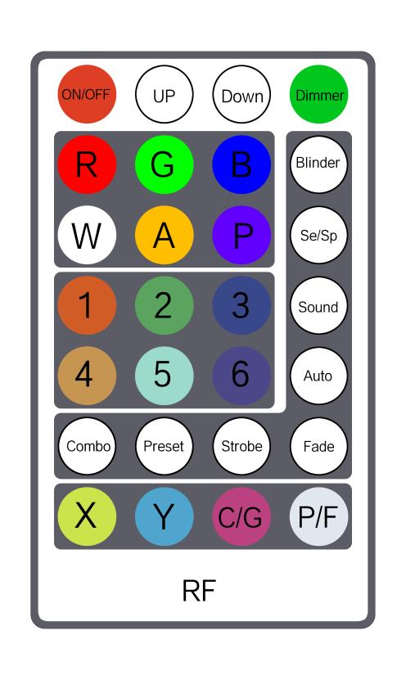
RF433 Remote Control Instructions：
1：Effective distance 20—50M
2：RF433 the remote control is only valid when the light is in master mode
3: This description is only valid for this light
Remote Control Instructions
ON/OFF | UP | DOWN | Total dimmer  (Up/down)
R  Red  (0—255 up/down) | G  Green  (0—255 up/down) | B  Blue  (0—255 up/down) | Blinder
W  White  (0—255up/down) | A  Amber  (N/A) | P  purple  (N/A) | Se/Sp  Sound sensitivity & Auto speed (up/down)  (Valid only Sound&Auto mode)
1 | 2 | 3 | Sound  (up/down)
4 | 5 | 6 | Auto  (up/down)
Combo  (Cbo1 Random)  (Cbo2 Beam only)  (Cbo3 5050RGB only)  (Cbo4 Beam+5050RGB)  (Cbo5 5050White only)  (Cbo6 Beam +5050White)  (Cbo7 5050RGB+5050White)  (Cbo8 Beam+5050RGB+5050White)  (Cbo9 Laser only)  (Cbo10Beam+Laser)  (Cbo11Laser+5050RGB)  (Cbo12Beam+Laser+5050RGB)  (Cbo13 Laser+5050White)  (Cbo14 Beam+Laser+5050White)  (Cbo15 Laser+5050RGB+5050White)  (Cbo16 The combination effect is fully illuminated) | Preset  Colour select  (up/down) | Strobe  (up/down) | Fade  (up/down)
X  (N/A) | Y  (N/A) | C/G  (N/A) | P/F  (N/A)

Technical Parameters:
Input voltage: AC110~240V
Power supply: 150W
Total power: 122
Light source: 2X38pcs 1W high-brightness LED patent LEDs, 8-segment control.
192pcs 5050RGB highlight, 24-segment control.
22pcs 5050White, 6-segment control.
One 150MARedLaser, one 370MAGreenLaser.
Beam angle: 3°
Strobe：1~30Hz
Channel: 23CH &101CH
Control mode: DMX, Sound control, auto-propelled, RF433, wireless DMX (optional)
Dimensions/Weight: 433*177*183mm/ 2.65kg
IP: IP20
Appearance: Metallic

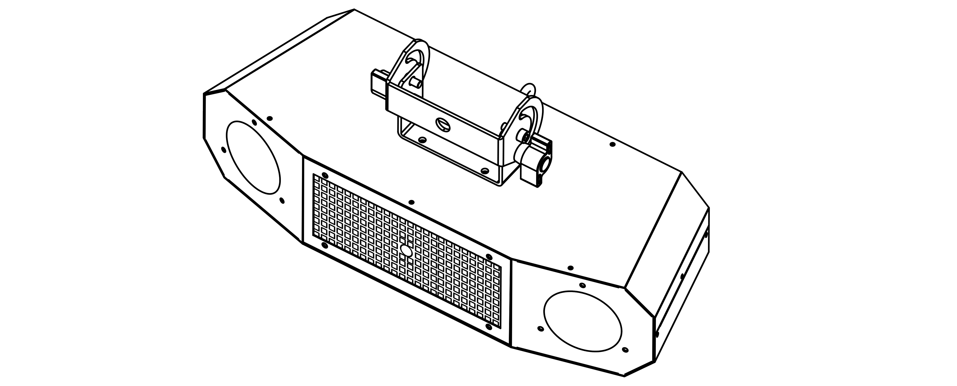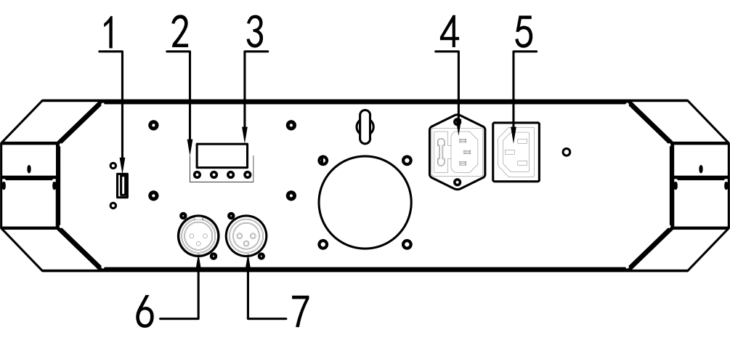

1、 USB:wireless
2、 Panel operation buttons: MENU, UP, Down, Enter
3、 LED display
4、 POWER OUT: Power output
5、 POWER IN: Power input
6、 DMX IN: 3-pin DMX signal input
7、 DMX OUT: 3-pin DMX signal output

