Product warranty card（Customer sheet）

Product name： Product model：
Factory No：
date of production： year month day
Customer Name： contact number：
Customer address：
- Warranty content：
Customer signature：
- Warranty content：
Customer signature：
- Warranty content：
Customer signature：
Instructions for flamethrower

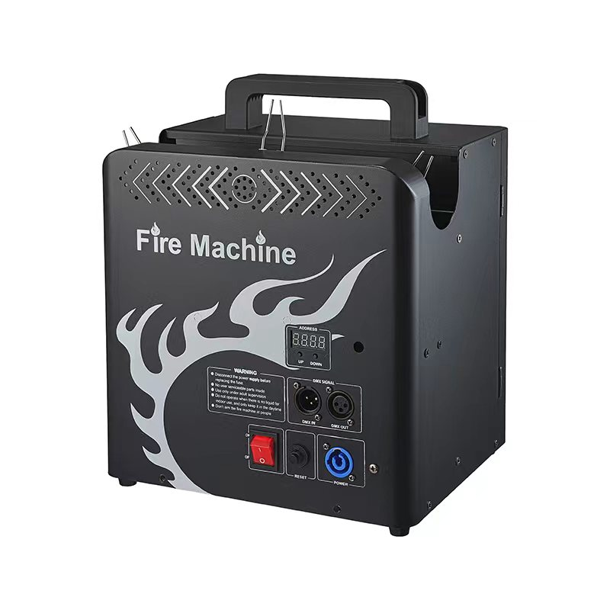

Product parameters
Length, width and height: 29 * 23 * 34
Gross weight: 8.3kg
Outer package size: 36 * 30 * 39cm
Voltage: 220V
Power: 300w
DMX channel: 5 channels
Fireball height: 3-4 meters
Fire column height: 2-3 meters
DMX console control is required. There are 5 channels in total
Channel 1: left nozzle
2 channels: middle nozzle
Channel 3: right nozzle
4 channels: three together
5 channels: mode switching (default is point spray. Push up is continuous spray, maximum 5 seconds.)
DMX address setting: two buttons at the bottom of the display screen plus/minus setting.
matters needing attention:
1. The flamethrower should be used outdoors as much as possible.
2. Professional control. The control must be disconnected or turned off when people leave.
3. Place it vertically and stably on the ground for use. Do not hang on the wall or upside down.
4. There shall be no people or combustible materials within the radius of 5 meters of the flame thrower.
5. For indoor use, the vertical height should be at least 8 meters.
6. It is best to use it in a windless environment. If you must use it in a windy environment, you must control the safe distance.
7. It is better to use the sparking oil and gas tank once and take it out after use.
The first reason is to ensure that each use can be in full state, and there will be no midway loss of gas or lack of gas affecting the effect.
The second reason is that it is very dangerous to take out the half bottle, which may cause leakage, splash and deflagration.
The third reason is that half a bottle is easy to forget or be discarded, which is easy to cause accidents.
8. When taking out the flame-jet oil and gas tank, make sure that the machine is powered off. There is no open fire nearby.

