LED Bee Eye 6-in-1

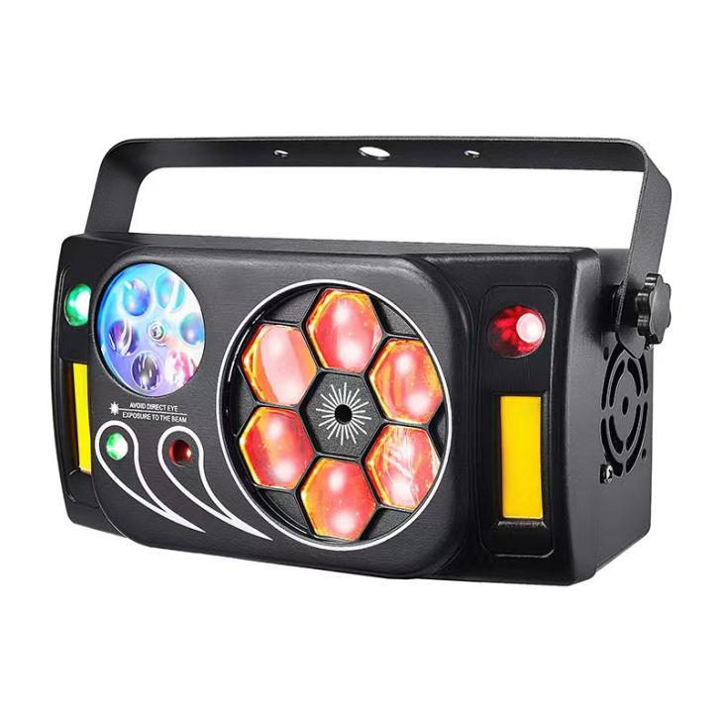

Product instructions for use

AC Voltage: AC100-240V, 50 / 60Hz
Total power: 80W
Feng eye: 6 RGBW four-in-one 8W lamp beads
Pattern: 3 pictures
Red and green laser: 1 red laser 650nm 1 green laser 532nm
Green light: 1 red laser 650nm 1 green laser 532nm
Strobe: 2 yellow light
Working mode: DMX512 signal / main-slave / self-walking / voice control / remote control
Remote control: wireless 433 MHZ

- Function Settings
menu | numeric value | description
A1 | 1~9 | Beacon's eyes are red and bright, and the motor speed is moving from slow to fast
A2 | 1~9 | The beacon eyes red green bright, the motor speed from slow to fast
A3 | 1~9 | Feng eyes red blue bright, the motor speed from slow to fast
A4 | 1~9 | The beacon is red and white bright, the motor speed from slow to fast
A5 | 1~9 | Pattern bright, the motor speed from slow to fast
A6 | 1~9 | Red and green laser bright, the motor speed from slow to fast
A7 | 1~9 | Strobe, strobe speed from slow to fast
A8 | 1~9 | The sky star red and green laser switch, the speed from slow to fast
C1 | 1~9 | Combination from the walk 1, the speed from slow to fast
C2 | 1~9 | Combination from the walk 2, the speed from slow to fast
S1 | 1~9 | Voice control 1, voice control sensitivity increases with the value
S2 | 1~9 | Voice control 2, voice control sensitivity increases with the increase of the value
S2 | 1~9 | Voice control 3, voice control sensitivity increases with the increase of the value, silent control light
D | 001~512 | DMX or from the machine
MENU is the menu switch key, UP, DOWN is the value switch key, and ENTER is the confirmation key.
- DMX control
channel | The channel value | functional description
CH1 | 0~255 | Total dimming
CH2 | 0~255 | Beacon red light dimming
CH3 | 0~255 | Beacon green light dimming
CH4 | 0~255 | Beacon blue light dimming
CH5 | 0~255 | Beacon eyes white light dimming
CH6 | 0~4 | There is no frequency flash in the eye
CH6 | 5~255 | There is no stroboscopic strobe, the larger the channel value, the faster the strobe speed
CH7 | 0~4 | Beacon motor stopped
CH7 | 5~255 | The beacon eye motor rotates clockwise, and the larger the channel value, the faster the speed
CH7 | 5~255 | The beacon eye motor rotates counterclockwise, and the larger the channel value is, the slower the speed is
CH8 | 0~255 | Pattern dimming
CH9 | 0~9 | The pattern motor stops
 | 10~255 | The pattern motor rotates, and the larger the channel value, the faster the speed
CH10 | 0~4 | The red laser is not bright
CH10 | 5~255 | Red laser bright
CH11 | 0~4 | Green laser is not bright
CH11 | 5~255 | Green laser bright
CH12 | 0~9 | The laser motor stops
CH12 | 5~255 | The laser motor rotates, and the larger the channel value, the faster the speed
CH13 | 0~4 | The sky star laser is not bright
CH13 | 5~127 | The sky star laser is red and bright
CH13 | 128~191 | The sky star laser is green and bright
CH13 | 192~255 | The sky star laser is red and green
CH14 | 0~49 | CH1~CH13 valid
CH14 | 0~49 | macro

Instructions for using the remote control
key | function
O N | opening the light
DMX | Console 512 mode
OFF | Closed light
SPEED- | Speed reduction
AUTO | Self-moving mode switch
SPEED+ | Speed and
MIC+ | Sound control sensitivity plus
VOICE | Sound control mode switch
MIC- | Sound control sensitivity decreased
1 | A1 pattern
2 | A2 pattern
3 | A3 pattern
4 | A4 pattern
5 | A5 pattern
6 | A6 pattern
7 | A7 pattern
8 | A8 pattern
9 | C1 pattern

