LED 8+8 RGBW STROBE

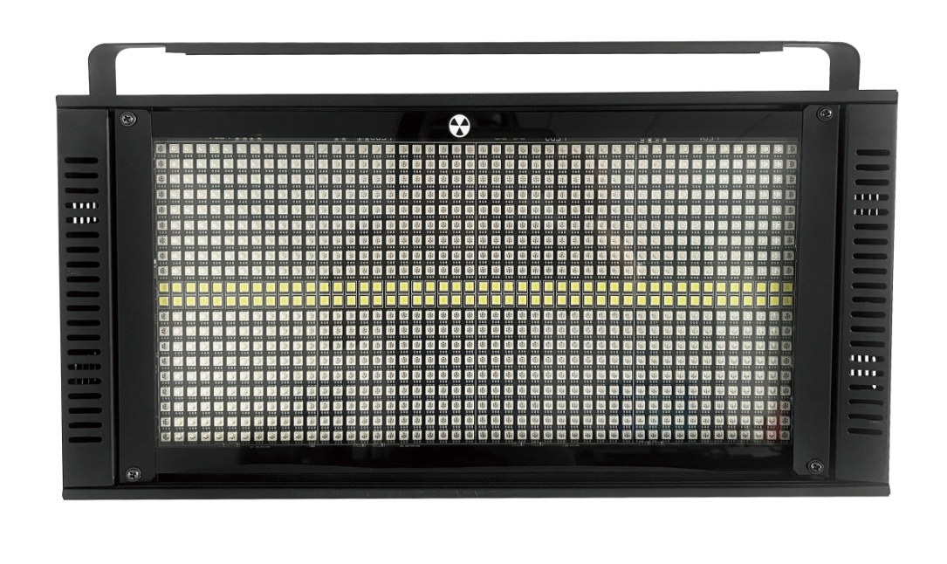

Instruction Manual

I. Display panel and key button definition
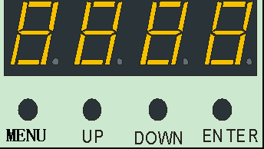
The menu confirms up and down
Food menu key: Select the function
Up key: parameter recurrence
Down key: The parameter is decreasing
Confirm key: Determine and save
Two, menu function
Press the menu button, then appear the menu table; up or down to modify the function parameters, confirm that the key saves the current function and parameters (power memory after saving).
Menu feature table:
A001 |  | A512 | Modify the address code (A001~A 512) up or down to confirm that the key is saved.
CH03 |  | CH39 | Switch the three CH04, CH11, CH32, CH39 channels up or down to confirm that the key is saved.
M000 |  | M083 | Three-in-one 84 (M000~M083), switch built-in effects up or down to confirm key preservation.
S000 |  | S255 | Modify the 3-in-one S000~ S255 (up or down) to confirm the key is saved.
M000 |  | M040 | Intermediate white light built-in effects 41 (M000~M040), switch the built-in effect up or down to confirm key preservation.
S000 |  | S255 | Modify the intermediate white light built-in effect running speed (S000~ S255) up or down to confirm that the key is saved.
Soud |  | Soud | Sound control mode.
R255 |  | R000 | Modify the red bead brightness (R000~ R255) up or down to confirm that the key is saved.
G255 |  | G000 | Modify the green bead Brightness (G000~ G255) up or down to confirm that the key is saved.
B255 |  | B000 | Modify the blue bead brightness (B000~ B255) up or down to confirm that the key is saved.
W255 |  | B000 | Modify the middle white bead brightness (W000~W255) up or down and confirm the key is saved.
T000 |  |  | Display temperature, such as T045 indicates that the current lamp temperature is 45℃; 10K thermistor is not installed, display T000.
III. Main and slave control
Two or more identical lamps are connected with DMX three-core signal line, lamps set to A001~A512 any address code, any host, other lamps are the slave display, all not flashing; with the host gradient, pulse, jump, sound control, self-departure effect, all slave synchronous gradient, pulse, jump, sound control and self-departure effect.
Special attention: 1. One set of lamps can only set up one host. If there are multiple hosts, all the lamps will flash and out of time.
All 2, lamps must be primary and primary when the DMX512 console is turned off.
Iv. Plant setting
At any address code of A001~A512, press the menu key for 5 seconds to enter the factory settings.Factory setting is mainly the functions of lamp output power per road, fan setting mode, setting temperature protection point and sending parameters. The factory sets any mode according to the dish single key for 5 seconds.
Factory Settings Table:
R 255 |  | R032 | Modify red bead current (R032-R 255 up or down), confirm key save, default R200.
G 255 |  | G032 | Modify green bead current (G 032-G255 up or down), confirm key save, default G200.
B 255 |  | B032 | Modify the blue bead current (up or down), confirm the key save, default B200.
W255 |  | W 032 | Modify the blue bead current (up or down), confirm the key save, default W240.
FAN0 |  | FAN1 | Fan setting: FAN0 beads illuminate to start the fan, FAN1 reaches the set temperature protection point to start the fan, confirm the key saving.
T040 |  | T 070 | Set the temperature protection point, modify the parameter up or down (40℃~70℃), press confirmation to save, default 65.
S end |  | S end | Send the parameters of local factory up or down to all other lamps connected by three-core signal lines; confirm that the transmission parameters exit by the menu key for 5 seconds, and cancel the confirmation key.

V. DMX512 console
After energon, all lamps address codes are set and all lamps are connected to the DMX512 console in parallel with three-core signal line, and the address code will stop flashing, indicating that the DMX512 console signal has been sent to the lamps, and the relevant functions are controlled with the DMX512 console according to each channel description.
CH04 channel description:
channel | Channel value | Basic function
1 | 000-255 | Red lamp beads for linear dimming
2 | 000-255 | Green lamp beads for linear dimming
3 | 000-255 | Blue lamp beads for linear dimming
4 | 000-255 | White lamp beads for linear dimming

CH11 channel description:
channel | Channel value | Basic function
1 | 000-255 | Total dimming
2 | 000-255 | Three in one frequency flash
3 | 000-255 | Three-in-one mode (see: VI. mode effect for details)
4 | 000-255 | Three-in-one mode speed
5 | 000-255 | Red lamp beads for linear dimming
6 | 000-255 | Green lamp beads for linear dimming
7 | 000-255 | Blue lamp beads for linear dimming
8 | 000-255 | White light frequency flash
9 | 000-255 | White light mode (see: VI. Mode effect for details)
10 | 000-255 | White light mode speed
11 | 000-255 | White light beads Linear dimming

CH32 channel description:
channel | Channel value | Basic function
1 | 000-255 | Paragraph 1 of 3-in-one red lamp beads for linear dimming
2 | 000-255 | Paragraph 1 of 3-in-one green light beads for linear dimming
3 | 000-255 | Paragraph 1 of 3-in-one blue light beads for linear dimming
4 | 000-255 | Paragraph 2 of 3-in-1 red light beads for linear dimming
5 | 000-255 | Paragraph 2 of 3-in-1 green light beads for linear dimming
6 | 000-255 | Paragraph 2 of 3-in-1 blue light beads for linear dimming
… | … | ……
22 | 000-255 | Paragraph 8 of 3-in-one red lamp beads with linear dimming
23 | 000-255 | Paragraph 8 of 3-in-one green light beads with linear dimming
24 | 000-255 | Paragraph 8 of 3-in-one blue light beads for linear dimming
25 | 000-255 | Paragraph 1: linear dimming of white light beads
26 | 000-255 | Paragraph 2: linear dimming of white light beads
27 | 000-255 | Paragraph 3: linear dimming of white light beads
28 | 000-255 | Paragraph 4: linear dimming of white light beads
29 | 000-255 | Paragraph 5: linear dimming of white light beads
30 | 000-255 | Paragraph 6 White light beads linear dimming
31 | 000-255 | Paragraph 7: linear dimming of white light beads
32 | 000-255 | Paragraph 8 The linear dimming of white light beads

CH39 channel description:
channel | Channel value | Basic function
1 | 000-255 | Total dimming
2 | 000-255 | Three in one frequency flash
3 | 000-255 | Three-in-one mode (see: six and three-in-one mode effect for details)
4 | 000-255 | Three-in-one mode speed
5 | 000-255 | White light frequency flash
6 | 000-255 | White light mode (see: VI. White light mode effect for details)
7 | 000-255 | White light mode speed
8 | 000-255 | Paragraph 1 of 3-in-one red lamp beads for linear dimming
9 | 000-255 | Paragraph 1 of 3-in-one green light beads for linear dimming
10 | 000-255 | Paragraph 1 of 3-in-one blue light beads for linear dimming
… | … | ……
29 | 000-255 | Paragraph 8 of 3-in-one red lamp beads with linear dimming
30 | 000-255 | Paragraph 8 of 3-in-one green light beads with linear dimming
31 | 000-255 | Paragraph 8 of 3-in-one blue light beads for linear dimming
32 | 000-255 | Paragraph 1: linear dimming of white light beads
33 | 000-255 | Paragraph 2: linear dimming of white light beads
34 | 000-255 | Paragraph 3: linear dimming of white light beads
35 | 000-255 | Paragraph 4: linear dimming of white light beads
36 | 000-255 | Paragraph 5: linear dimming of white light beads
37 | 000-255 | Paragraph 6 White light beads linear dimming
38 | 000-255 | Paragraph 7: linear dimming of white light beads
39 | 000-255 | Paragraph 8 The linear dimming of white light beads

VI. Mode effect
Three-in-one mode effect:
Channel value | Mode code | Effect
0-2 | 0 | No effect
3-5 | 1 | The R red beads are fully on.
6-8 | 2 | The G green beads are fully on.
9-11 | 3 | The B blue beads are fully on.
12-14 | 4 | The RG red and green staining lights are fully on.
15-17 | 5 | The RB red and blue stained lights are fully on.
18-20 | 6 | The GB green and blue stained lights are fully on.
21-23 | 7 | The RGB red, green and blue stained lights are all on.
24-26 | 8 | Integrated mode code-name 1-7 cycle.
27-29 | 9 | Gradient
30-32 | 10 | Variation
33-35 | 11 | A section of red light bead running a horse.
36-38 | 12 | A section of green lamp bead running a horse.
39-41 | 13 | A section of blue lantern bead horse racing.
42-44 | 14 | A section of red and green dyeing light horse racing.
45-47 | 15 | A section of red and blue stained light horse racing.
48-50 | 16 | A section of green and blue stained light for horse racing.
51-53 | 17 | A section of red, green and blue stained light horse racing.
54-56 | 18 | Integrated mode code name 11-17 cycle.
57-59 | 19 | Two section of red lamp bead horse racing.
60-62 | 20 | Two section of green lamp bead horse racing.
63-65 | 21 | Two section of blue lights bead horse racing.
66-68 | 22 | Two section of red and green staining light horse racing.
69-71 | 23 | Two section of red and blue stained light horse racing.
72-74 | 24 | Two section of green and blue dyeing light horse racing.
75-77 | 25 | Two sections of red, green and blue dyeing light horse racing.
78-80 | 26 | Integrated mode code name 19-25 cycle.
81-83 | 27 | A section of red lamp beads was refreshed.
84-86 | 28 | A section of green light beads is refreshed.
87-89 | 29 | A section of blue light beads was refreshed.
90-92 | 30 | A section of red and green staining light is refreshed.
93-95 | 31 | A section of the red and blue stained light was refreshed.
96-98 | 32 | A section of the green and blue stained light was refreshed.
99-101 | 33 | A section of red, green and blue stained light is refreshed.
102-104 | 34 | Integrated mode code name 27-33 cycle.
105-107 | 35 | Each section of red light beads at the head and tail is refreshed back and forth.
108-110 | 36 | Each section of green light beads is refreshed back and forth.
111-113 | 37 | Each section of blue light beads from the head and tail is refreshed back and forth.
114-116 | 38 | The head and end of each section of red and green staining lights are refreshed back and forth.
117-119 | 39 | Each head and tail section of red and blue stained lights was refreshed back and forth.
120-122 | 40 | Each head and tail section of green and blue stained lights is refreshed back and forth.
123-125 | 41 | Each section of head and tail of red, green and blue staining lights was refreshed back and forth.
126-128 | 42 | Integrated mode code name 35-41 cycle.
129-131 | 43 | Two segments of red light beads run back and forth.
132-134 | 44 | Two segments of green light beads were running back and forth.
135-137 | 45 | Two segments of blue light beads were running back and forth.
138-140 | 46 | Two segments of red and green stained lights run back and forth.
141-143 | 47 | Two red and blue stained lights run back and forth.
144-146 | 48 | Two segments of green and blue stained lights run back and forth.
147-149 | 49 | Two red, green and blue stained lights run back and forth.
150-152 | 50 | Integrated mode code name 43-49 cycle.
153-155 | 51 | A section of red beads and a section of green beads run back.
156-158 | 52 | A section of green beads and a section of blue beads run back.
159-161 | 53 | A section of blue light beads and a section of red and green stained lights run back.
162-164 | 54 | A section of red and green staining light and a section of red and blue stained light ran back.
165-167 | 55 | A section of red and blue staining light and a section of green and blue staining light run back.
168-170 | 56 | A section of green and blue stained light and a section of red, green and blue stained light run back.
171-173 | 57 | A section of red, green and blue stained lights and a section of red light beads run back.
174-176 | 58 | Integrated mode code name 51-57 cycle.
177-179 | 59 | Two segments of red lamp bead square running.
180-182 | 60 | Two segments of green lamp ball square running.
183-185 | 61 | Two segments of the blue light bead square run.
186-188 | 62 | Two sections of red and green stained lights square running.
189-191 | 63 | Two segments of red and blue stained lights square run.
192-194 | 64 | Two segments of green and blue stained lights square run.
195-197 | 65 | Two red green blue stained light square run.
198-200 | 66 | Integrated mode code name 59-65 cycle.
201-203 | 67 | A section of red lamp running a residual shadow.
204-206 | 68 | A section of green lantern beads have a residual shadow.
207-209 | 69 | A section of blue lantern beads have a residual shadow.
210-212 | 70 | A section of red and green dyeing light horse racing has a residual shadow.
213-215 | 71 | A section of red and blue stained lights with residual shadow.
216-218 | 72 | A section of green and blue stained lamp horse racing has a residual shadow.
219-221 | 73 | A section of red, green and blue dyeing light horse racing with residual shadow.
222-224 | 74 | Integrated mode code name 105-111 cycle.
225-227 | 75 | A section of red lamp beads was piled up.
228-230 | 76 | The section of green lamp beads pile up.
231-233 | 77 | A section of blue lamp beads was piled up.
234-236 | 78 | A section of red and green stained lights accumulates.
237-239 | 79 | A section of red and blue stained lights was accumulated.
240-242 | 80 | A section of green and blue stained lights accumulates.
243-245 | 81 | A section of red, green and blue stained lights was accumulated.
246-248 | 82 | Integrated mode code name 113-119 cycle.
249-251 | 87 | Colorful accumulation.
252-254 | 88 | Colorful flow.
255 | 89 | Mode code name Mode code name 11~81, which can push and pull the RGB to change the background color.

White light mode effect:
Channel value | Mode code | Effect
0-5 | 1 | No effect
6-11 | 2 | The first paragraph white light
12-17 | 3 | The second paragraph white light
18-23 | 4 | Paragraph 3 White Light
24-29 | 5 | Paragraph 4 White Light
30-35 | 6 | Paragraph 5 White Light
36-41 | 7 | Paragraph 6 White Light
42-47 | 8 | Paragraph 7 White Light
48-53 | 9 | Paragraph 8 White Light
54-59 | 19 | A section of white light runs from left to right.
60-65 | 20 | A section of white light runs from right to left.
66-71 | 23 | Two section of white light from left to right horse racing.
72-77 | 24 | The second section of white light from right to left horse racing.
78-83 | 27 | Three sections of white light run from left to right horse.
84-89 | 28 | Three sections of white light from right to left horse racing.
90-95 | 30 | A section of white light was racing back and forth.
96-101 | 33 | Two sections of white light racing back and forth.
102-107 | 34 | Three sections of white light are racing back and forth.
108-113 | 37 | A white-light tail collided from left to right.
114-119 | 39 | A white-light tail fell from right to left.
120-125 | 40 | A white-light tail fell from left to right.
126-131 | 43 | A white-light tail fell from right to left.
132-137 | 45 | A white light tail runs back and forth.
138-143 | 47 | A piece of white light is refreshed from left to right.
144-149 | 49 | A piece of white light is refreshed from right to left.
150-155 | 51 | Each section of white light refreshes in the middle.
156-161 | 53 | The middle white light is refreshed at both ends
162-167 | 55 | Each section of white light ran back and forth.
168-173 | 57 | A section of white light accumulates from left to right.
174-179 | 59 | A section of white light accumulates from right to left.
180-185 | 61 | White light waves range from left to right.
186-191 | 63 | White light waves are from right to left.
192-197 | 65 | Each two wave of white light merges into the middle.
198-203 | 67 | A wave of white light is separated from the middle to the two ends.
204-209 | 69 | Four segments interval between a white light running back and forth.
210-215 | 71 | Four segments of the connection with white light running back and forth.
216-221 | 73 | A section of white light squirfrom left to right.
222-227 | 75 | A section of white light squirfrom right to left.
228-233 | 77 | A gradient white light moves from left to right before finally shining back.
234-239 | 79 | Two white light pendulum.
240-245 | 81 | After a section of white light accumulates, another paragraph disappears.
246-251 | 87 | The white light collided at both ends and grows.
252-255 | 88 | Comprehensive mode.

VII. Technical parameters:
Voltage: AC100~240V 50/60HZ
Power: 200W
beads: 8645050 three-color LED beads + 96 white LED
Control mode: DMX512, self-walking, main and slave, sound control, with RDM function.
channel: CH04, CH11, CH32, CH39
Dimming: 32bit 0~100% linear dimming
Features: 8 + 8 section horse racing + staining + flash
Operating temperature: -30 ° ~50 degrees
Flashbe frequency: 1~30HZ
Appearance: Metal, black
Connection mode: DMX512 input / output / power input / output.
IP Level: IP20

