operating instruction
LED firemeteor

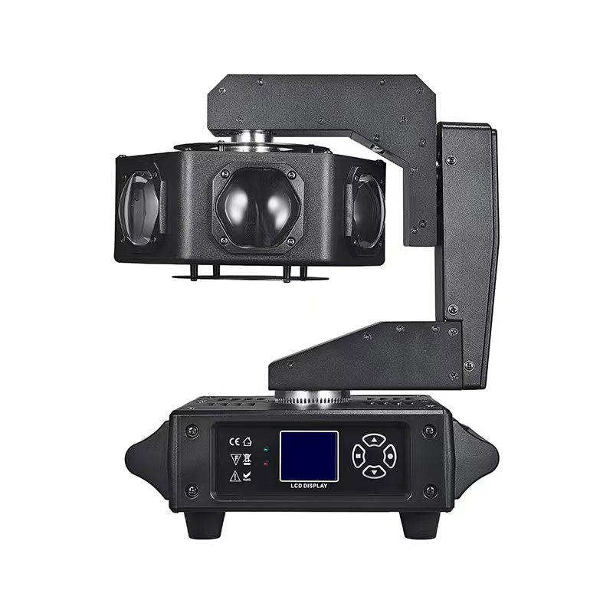

Product information is subject to the actual configuration, if there is any change, we will not give further notice. We reserve the right of final interpretation.
1. Product technical parameters:
- Rated voltage: AC100-240V, 50 / 60 HZ.
- Rated power: 240W
- Light beads: 6 of 40W RGBW
- Cooling system: aluminum cooling, air cooling
- Lens: a high-precision optical lens set
- Beam angle: 2 degrees
- Dimming: 0~100% Linear dimming
- Strobe: 0- -20 times / second
- Control mode: DMX512 signal / primary / slave / synchronization
- Panel display: premium 1.77-inch color LCD screen
- channel:14CH/16CH
- Scanning Angle: X axis 540, Y axis 320, Z axis infinite rotation
- Scan fine-tuning: 8 / 16 Bit
- Color: an independent 4-color effect, which can be unlimited mixed color combination
- Product size: 338 * 265 * 207
- Product weight: 5.8 Kg

2. The LCD screen front page description
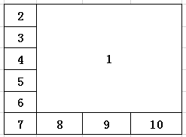
1 — The large font displays the current DMX address
2- -Click to switch between the operation mode
3-Click Inturn display screen 4-Click Settings, system language 5-Click to reset the lamp
6-Click to set the DMX Channel mode, optional (14 CH / 16 CH)
7- -Click to enter the Settings menu
7.1 Operation mode: DMX: the operation is controlled by the DMX512 console
Self-go: run the program set by the manufacturer
Voice control: to run the program set by the manufacturer
Manual: Set the value of the channel manually
7.2 DMX Address: 0- -512
7.3 Channel mode: 14 CH / 16 CH
7.4 Voice control sensitivity: 0-100
7.5 Dimming curve: linear / square / insquare / S curve
7.6 Dimming speed: smooth / fast
7.7 X reversal: on / off
7.8 Y reversal: on / off
7.9 XY Exchange: on / off
7.10 XY encoder: on / off
7.11 No DMX signal: Hold: Keep the last state when the signal is lost. Zero: all other channels.
7.12 Screen reverse: Yes / No
7.13 Screen backlight: on / off
7.14 Language: Chinese / English
7.15 Motor reset: all motors are reset
7.16 Restore factory settings: restore all settings to factory state (fine data, bulb time records will not be restored). Note: Because the recovery of data requires a long time to read and write the memory, please do not perform this operation when the motor rotates at a high speed to avoid delayed chip processing
8- -Click to query the lamp information
8.1 Software version: displays the current software version number
8.2 Total use time: the actual time is subject to the screen display screen
8.3 Time of use of this time: the actual time is subject to the screen display screen
8.4 Total bright soaking time: the actual time is subject to the screen display screen
8.5 The bright bubble time: the actual time is subject to the screen display screen
8.6 Equipment temperature: the actual temperature is subject to the screen display screen
8.7 DMX channel values: Displays the DMX value for the selected channel.
8.8 Reset the error record: Display the error message.
9- -Click to enter the manual control mode
9.1 Level: 0-255
9.2 Vertical: 0-255
9.3 Horizontal / vertical speed: 0-255
9.4 Rotation: 0-255
9.5 dimming: 0-255
9.6 strobe: 0-255
9.7 Red: 0-255
9.8 Green: 0-255
9.9 Blue: 0-255
9.10 White: 0-255
10-Click to enter the advanced menu (enter the password to enter the 223)
10.1 Maximum lighting time: Set the lighting time
10.2 Clear bubble time: clear bright bubble time
10.3 Reset calibration: Reset calibration: zero-position fine-tuning of the lamp motor
10.3.1 Level: -127-128
10.3.2 Vertical: -127-128
10.3.3 Rotation: -127-128
10.4 Display manufacturer: Manufacturer's trademark display
Note: Menu special instructions
- Press no operation, wait for 30 seconds, automatically return to the main menu, DMX mode has a signal, green indicator light on, reset error, red indicator light on
- Two or more identical lamps are connected with 3-core signal lines, any host is set as the demonstration program, and the other machine automatically recognizes the signal and enters the slave mode
3. Touch the key for the instructions
1. MENU / return: Click to return to the previous page
2, UP / on: represents up, add the key
3, DOWN / lower: represents the down, minus the key
4. ENTER / OK: Click Save information
4. DMX512 Channel table
14CH | 16CH | explain | DMX price | function
1 | 1 | X axle | 0-255 | The X-axis operation is 0° - -540°
 | 2 | X axis fine-tuning | 0-255 | X axis fine-tuning
2 | 3 | Y axle | 0-255 | The Y-axis operation is 0° - -320°
 | 4 | Y axis fine-tuning | 0-255 | Y axis fine-tuning
3 | 5 | The X-axis / Y-axis speed | 0-255 | Speed is varied from, fast to slow
4 | 6 | Z axle | 0-127 | 0° - -360° travel positioning
4 | 6 | Z axle | 128-191 | Rotate clockwise, from fast to slow
4 | 6 | Z axle | 192-255 | Rotate counterclockwise, from slow to fast
5 | 7 | Total dimming | 0-255 | 0-100% Linear dimming
6 | 8 | stroboflash | 0-255 | The strobe speed is varied from slow to fast at 1-20Hz
7 | 9 | red | 0-255 | 0-100% Linear dimming
8 | 10 | green | 0-255 | 0-100% Linear dimming
9 | 11 | blue | 0-255 | 0-100% Linear dimming
10 | 12 | white | 0-255 | 0-100% Linear dimming
11 | 13 | LED macro | 0-5 | NF
11 | 13 | LED macro | 6-10 | Color gradient effect
11 | 13 | LED macro | 11-20 | Color pulse change effect
11 | 13 | LED macro | 21-212 | Color combination
11 | 13 | LED macro | 213-255 | Color jump effect
12 | 14 | LED macro function speed | 0-255 | Speed from slow to fast
13 | 15 | macro | 0-15 | NF
13 | 15 | macro | 16-127 | Go to the program
13 | 15 | macro | 128-255 | Sound control program
14 | 16 | reset | 0-249 | NF
14 | 16 | reset | 250-255 | Wait for the 5S, and the lamp is reset

