3240W-G4
32x40W Wall Washer RGBW 4in1 LED Light

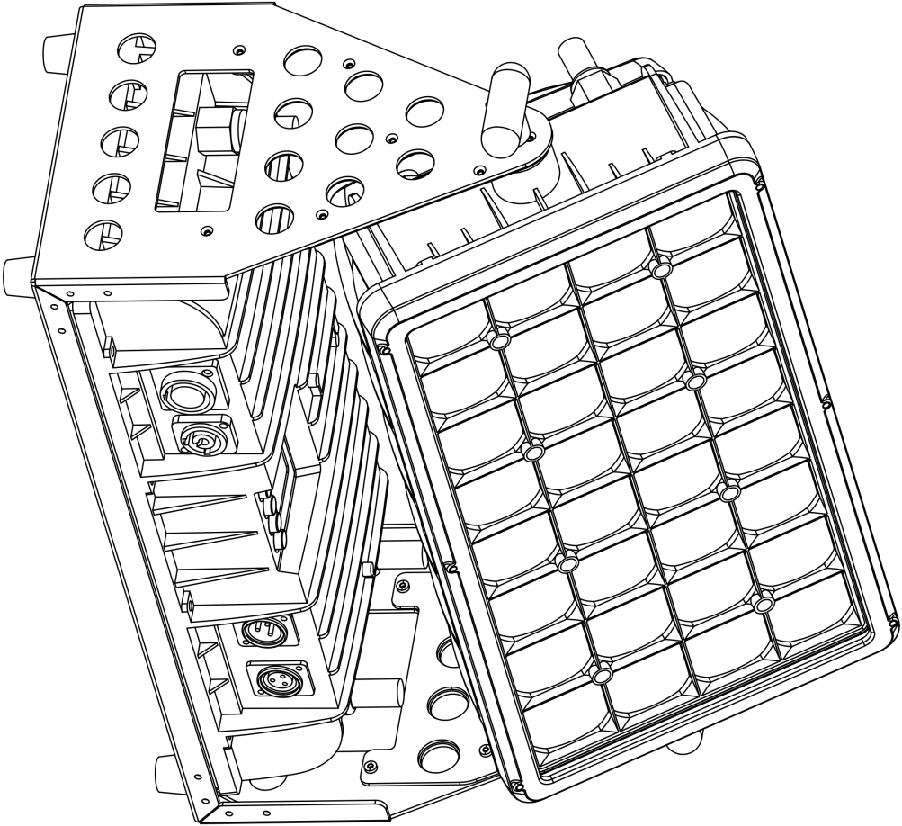

User manual
Please read the instructions carefully before use

TABLE OF CONTENTS

1. Safety Instructions 3-4
2. Technical Specifications 5
3. How To Control The Unit 6-12
4. shape 11
5. Trouble shooting 14
6. Fixture Cleaning 14

statement
The product has well capability and intact packing when leave factory. All of the user should comply with warning item and manual, any misuse cause of the damages are not included in our guarantee, and also can’t be responsible for any malfunction & problem owing to ignore the manual.

1. Safety Instructions
Please keep this User Guide for future consultation. If you sell the unit to another user, be sure that they also receive this instruction booklet.

 Unpack and check carefully there is no transportation damage before using the unit.
 Before operating, ensure that the voltage and frequency of power supply match the power requirements of the unit.
 It’s important to ground the yellow/green conductor to earth in order to avoid electric shock.
 The unit is for indoor use only. Use only in a dry location.
 The unit must be installed in a location with adequate ventilation, at least 50cm from adjacent surfaces. Be sure that no ventilation slots are blocked.
 Disconnect main power before replacement or servicing.
 Make sure there are no flammable materials close to the unit while operating as it is fire hazard.
 Use safety cable when fixes this unit. Do not handle the unit by taking its head only, but always by taking its base.
 Maximum ambient temperature is Ta: 40℃. Do not operate it where the temperature is higher than this Unit surface temperature may reach up to 85℃. Do not touch the housing bare-hand during its operation. Turn off the power and allow about 15 minutes for the unit to cool down before replacing or serving.

 In the event of serious operating problem, stop using the unit immediately. Never try to repair the unit by yourself. Repairs carried out by unskilled people can lead to damage or malfunction. Please contact the nearest authorized technical assistance center. Always use the same type spare parts.

 Do not touch any wire during operation as high voltage might be causing electric shock.

Warning:
 To prevent or reduce the risk of electrical shock or fire, do not expose the unit to rain or moisture.
 Do not open the unit within five minutes after switching off.
 The housing, the lenses, or the ultraviolet filter must be replaced if they are visibly damaged.
Caution:
There are no user serviceable parts inside the unit. Do not open the housing or attempt any repairs yourself. In the unlikely event your unit may require service, please contact your nearest dealer.
Installation:
The unit should be mounted via its screw holes on the bracket. Always ensure that the unit is firmly fixed to avoid vibration and slipping while operating. And make sure that the structure to which you are attaching the unit is secure and is able to support a weight of 10 times of the unit’s weight. Also always use a safety cable that can hold 12 times of the weight of the unit when installing the fixture.
The equipment must be fixed by professionals. And it must be fixed at a place where is out of the touch of people.

2. Technical Specifications
Light Sources: 32 x 60W 4in1 RGBW LED
Light Angle: 38°
COB + PMMA High Quality Optical Lens
Power Consumption: 1050W
Power Voltage: AC 100-240V, 50/60Hz
Dimension: 514*222*324 mm
Net Weight: 15 kg
Gross Weight: 20 kg Size:62*43*34.5cm (Carton package 1in1)
Gross Weight:75.65 kg Size:80*68.5*53cm (Flight case package 3in1)

Control
DMX Channel: 9/14 Channels
Control Modes: DMX512/Master-Slave/Auto Run/Music/RDM/Manual
Pan/Tilt
Pan/Tilt: 540°or 360°in optional / 270°
Pan/Tilt Resolution: 8/16 bit
Construction
Display:1.8 TFT colorful Display
Data In/Out socket: 3-pin XLR sockets
Power Socket: Power Con in/out
Protection Rating: IP65
Features
Full optical domain dimming, with 65536 level dimming accuracy;
Fast strobe 1-25Hz; Preset multiple color macro effect ;
Dimmer: 0~100% smooth dimming

3. How To Control The Unit
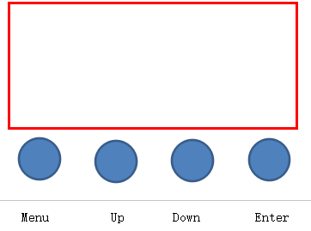

Display:
MENU To select the programming functions
DOWN To go backward in the selected functions
UP To go forward in the selected functions
ENTER To confirm the selected functions

Set DMX Address Code
1 Press "Menu" to "Set DMX Address", and press "ENTER" keys to enter into
2 Show "Set DMX Address DMX Address:001", Press the "UP and DOWN"
keys to amended
- Press "ENTER" keys to save and Exit, Press the "MENU" Keys does not save and Exit

Menu | 1.Mic Sense | 001--100 |  |  |  | Sound control adjust sensitiveness
Menu | 2.Language | 1.English
Menu | 2.Language | 2.Chinese
Menu | 3.No Signal | 1.Black Out
Menu | 3.No Signal | 2.Hold
Menu | 4. Fan Set | 1. Auto
Menu | 4. Fan Set | 2. Low
Menu | 4. Fan Set | 3. High
Menu | 5.Default | 1.Yes
Menu | 5.Default | 2.No
Menu | 6.Adjust | Pass Word |  |  | ****
Menu | 6.Adjust | 1.Red：0--255 |  |  | Changing the value of R/G/B/W can adjust the white balance, but the value can’t be set to zero
Menu | 6.Adjust | 2.Green：0--255
Menu | 6.Adjust | 3.Blue：0--255
Menu | 6.Adjust | 4.White：0--255
Address | Set address code 001--512
Rever | 2..Display |  | 1.Yes |  |  |  | Display forward and reverse
Rever |  |  | 2.No |  |  |  | Display forward and reverse
Inform | 1.CH Value |  |  | Display all channel values
Inform | 2.Temp/℃ |  |  | Display led board temperature
Inform | 3.Soft v.xxx |  |  | Software version number
Mode | 1.DMX512
Mode | 2.Auto |  |  | 1.Master
Mode |  |  |  | 2.Alone
Mode | 3.Sound |  |  | 1.Master
Mode |  |  |  | 2.Alone
Mode | 4.Manual | Master |  |  | 1.Red：0--255
Mode | 4.Manual |  |  |  | 2.Greed：0--255
Mode | 4.Manual |  |  |  | 3.Blue：0--255
Mode | 4.Manual |  |  |  | 4.White：0--255
Mode | 4.Manual | Alone |  |  | 5. Strobe：0-255
Channel | 1.9Channels
Channel | 2.14Channels

DMX channel´s functions and values (9/14DMX channels):
Channel Model 1 - CH9
Channel | Display | Function | Value
CH-1 | Dimming | From dark to bright | 0 --- 255
CH-2 | Strobe | Light up | 0 --- 3
CH-2 | Strobe | From slow to fast（1HZ-25HZ） | 4 --- 203
CH-2 | Strobe | Random strobe | 204 --- 255
CH-3 | Red | From dark to bright | 0 --- 255
CH-4 | Green | From dark to bright | 0 --- 255
CH-5 | Blue | From dark to bright | 0 --- 255
CH-6 | White | From dark to bright | 0 --- 255
CH-7 | Linear Color Temperature | No | 0----4
CH-7 | Linear Color Temperature | Color temperature from warm to cool | 5-----255
CH-8 | Macro Color | No | 0-----9
CH-8 | Macro Color | Macro Color-1 | 10----14
CH-8 | Macro Color | Macro Color-2 | 15----19
CH-8 | Macro Color | .......... | ......5 numbers 1 effect
CH-8 | Macro Color | Macro Color-14 | 75----79
CH-8 | Macro Color | Macro Color-15 | 80----255
CH-9 | Dimming Model | Model -1 | 0 --- 49
CH-9 | Dimming Model | Model -2 | 50 --- 99
CH-9 | Dimming Model | Model -3 | 100 --- 149
CH-9 | Dimming Model | Model -4 | 150 --- 255

Channel Model 2 – CH14
Channel | Display | Function | Value
CH-1 | Red | From dark to bright | 0 --- 255
CH-2 | Red adjustment | Red adjustment | 0 --- 255
CH-3 | Green | From dark to bright | 0 --- 255
CH-4 | Green adjustment | Green adjustment | 0 --- 255
CH-5 | Blue | From dark to bright | 0 --- 255
CH-6 | Blue adjustment | Blue adjustment | 0 --- 255
CH-7 | White | From dark to bright | 0 --- 255
CH-8 | White adjustment | White adjustment | 0 --- 255
CH-9 | Dimming | From dark to bright | 0 --- 255
CH-10 | Dimming adjustment | Dimming adjustment | 0 --- 255
CH-11 | Strobe | Light up | 0 --- 3
CH-11 | Strobe | From slow to fast（1HZ-25HZ） | 4 --- 203
CH-11 | Strobe | Random strobe | 204 --- 255
CH-12 | Linear Color Temperature | No function | 0----4
CH-12 | Linear Color Temperature | Color temperature from warm to cool | 5-----255
CH-13 | Macro Color | No | 0 --- 9
CH-13 | Macro Color | Macro Color-1 | 10-- 14
CH-13 | Macro Color | Macro Color-2 | 15-- 19
CH-13 | Macro Color | .......... | 5 numbers 1 effect
CH-13 | Macro Color | Macro Color -14 | 75 --- 79
CH-13 | Macro Color | Macro Color-15 | 80--- 255
CH-14 | Dimming Model | Model -1 | 0 --- 49
CH-14 | Dimming Model | Model -2 | 50 --- 99
CH-14 | Dimming Model | Model -3 | 100 --- 149
CH-14 | Dimming Model | Model -4 | 150 --- 255

LUX

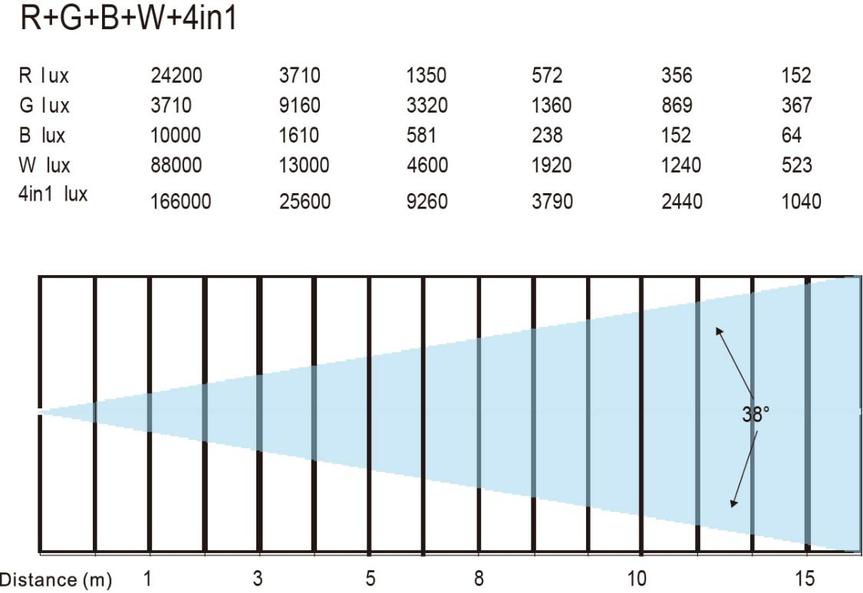

5.Shape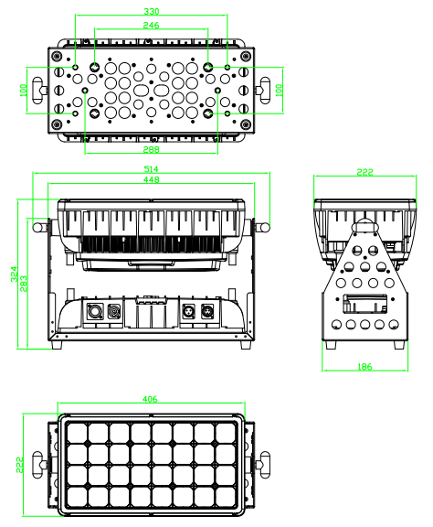

6. Trouble shooting
Following are a few common problems that may occur during operation. Here are some suggestions for easy troubleshooting:

A. The unit does not work, no light and the fan does not work
1. Check the connection of power and main fuse.
2. Measure the mains voltage on the main connector.
3. Check the power on LED.
B. Not responding to DMX controller
1. DMX LED should be on. If not, check DMX connectors, cables to see if link properly.
2. If the DMX LED is on and no response to the channel, check the address settings and DMX polarity.
3. If you have intermittent DMX signal problems, check the pins on connectors or on
PCB of the unit or the previous one.
4. Try to use another DMX controller.
5. Check if the DMX cables run near or run alongside to high voltage cables that may cause damage or interference to DMX interface circuit.
C. One of the channels is not working well
1. The stepper motor might be damaged or the cable connected to the PCB is broken.
2. The motor’s drive IC on the PCB might be out of condition.
6. Fixture Cleaning
The cleaning of internal and external optical lenses and/or mirrors must be carried out periodically to optimize light output. Cleaning frequency depends on the environment in which the fixture operates: damp, smoky or particularly dirty surrounding can cause greater accumulation of dirt on the unit’s optics.
• Clean with soft cloth using normal glass cleaning fluid.
• Always dry the parts carefully.
• Clean the external optics at least every 20 days. Clean the internal optics at least every 30/60 days.

