Instruction manual
Small bee Smart trigeminal pattern + bee's eye

Thank you for choosing our trigeminal pattern + bee's eye,For your personal safety and better use of this product,Please read the manual carefully before using,Follow the procedure,To avoid misuse of personal safety damage and lamp damage.

- Packing list
After unpacking,Please check the product is qualified,Count all accessories.NO, please contact the distributor!
number | Name | Color | Unit | Quantity
1 | Lamps and lanterns | Black | Station | 1
2 | Power Cord | Black | Ordinance | 1
3 | Handle | Black | PCS | 1
4 | Hexagon screws | Black | PCS | 2
5 | Instructions | Black and white | PCS | 1

- Appearance and LED Function
Switch settings by pressing a button：
*Click“MENU”Key switch function.
*Click“UP/DOWN”Switch function or set address code.
*After switching functions，Click“ENTER”Key save function.
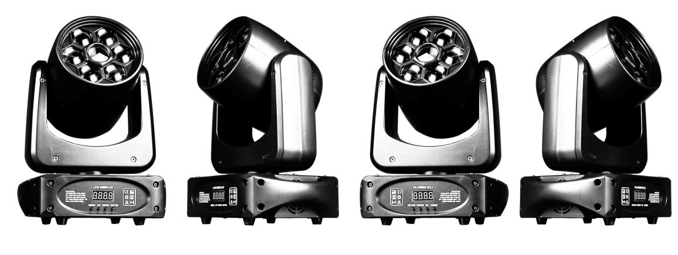
三、Technical parameters
number | Category | Parameter
1 | Power supply | AC95V-245V/50Hz
2 | Product power | 150W
3 | Pattern parameters | 8 PCS patterns, 8 PCS colors
4 | Lamp beads | 1 80W white light lamp bead, 6 5050 10W RGBW lamp beads
5 | Control | DMX512, 15 channels for international use
6 | Mode of operation | DMX512, master/slave, self-walking, voice control
7 | Dimming mode | 0~100% ultra-smooth dimming
8 | Strobe | 20 times per second
9 | Heat dissipation | Aluminum products cooling, forced cooling fan

四、DMX Channel function:
This product have 15 channels，Specific controls are as follows:
channels | Function | DMX Value | Description
1 | X-axis motor | 0-255 | 0~255 0-540 degree rotation
2 | Y-axis motor | 0-255 | 0~255 0-180 degree rotation
3 | XY axis motor speed | 0-255 | 0~255 speed from fast to slow
4 | dimming | 0-255 | Linear dimming from dark to light
5 | Stroboscopic | 0-9 | None
5 | Stroboscopic | 10-255 | Slow to fast
6 | colour disk | 0-255 | 0-35 (switch one color every 5 intervals), 35-127 (the last color), 127-255 (color moves from fast to slow)
7 | Pattern plate | 0-255 | 0-35 (switch one pattern every 5 intervals), 35-127 (the last pattern), 127-255 (the pattern moves from fast to slow)
8 | Z turntable | 0-255 | 0-127 (0-360 degrees), 128-191 (speed from slow to fast) 192-255 speed from fast to slow
9 | Bee eye total dimming | 0-255 | Linear dimming from dark to light
10 | Bee-eye strobe | 0-9 | No function
10 | Bee-eye strobe | 10-255 | Slow to fast
11 | red | 0-255 | Linear dimming from dark to light
12 | green | 0-255 | Linear dimming from dark to light
13 | blue | 0-255 | Linear dimming from dark to light
14 | white | 0-255 | Linear dimming from dark to light
15 | Macro function | 0-50 | Channels 1 to 14 are valid
15 | Macro function | 51-150 | autorun
15 | Macro function | 150-250 | voice
15 | Macro function | 251-255 | 3 second reset
menu
addr | A001-A512 | Set 512 address
Chnd | 15ch | Display the number of channels
Shou(running mode) | d512 | DMX512 mode
Shou(running mode) | auto | Self-propelled mode
Shou(running mode) | sond | Audio Mode
Sens | 0-100 | Voice control zero density setting
LED | oFF | Display is always on
LED | on | how Hibernate
Disp | OFF | Show Forward
Disp | ON | Show Reverse
rst | Yes/no | Manual reset

五、Maintenance
Do not stare at the luminescent body for a long time，It hurts the eyes;
Clean regularly Lens Keep the brightness and Extension Lamps and lanterns Service life.

